Archetypes and Basic Strategies of Technology Decisions
Bernhard Lingens, Stephan Winterhalter, Lukas Krieg, and Oliver Gassmann

bios below
Bernhard Lingens is a visiting researcher at Imperial College London, England. Formerly, he worked as a PhD student, project manager, and research associate at the Institute of Technology Management, University of St. Gallen, Switzerland. He has collaborated with renowned firms from various industries, such as automotive, engineering, electronics, medical engineering, and life sciences. His research and publication interests include the attention-based view of the firm, organizational decision making, technology decisions, technology foresight, and technology evaluation. He holds a Master of Science in business and engineering from the Ilmenau University of Technology, Germany. bernhard.lingens@unisg.ch
Stephan Winterhalter is a visiting scholar at IESE Business School in Barcelona, Spain. His research focuses mainly on innovation for emerging markets and on business models. His work has been published in Research-Technology Management, R&D Management and Small Business Economics. He holds a PhD and a Master’s degree from the University of St. Gallen, Switzerland where he worked at the Institute of Technology Management. stephan.winterhalter@unisg.ch
Lukas Krieg is a relationship manager at Callaghan Innovation, New Zealand. Formerly, he was a senior consultant at BGW AG, a Swiss innovation management consulting firm working with large, Europe-based multinationals. He established and led the commercial research team at the Auckland University of Technology (AUT) in New Zealand, where he worked on more than 100 research and innovation projects with industry clients and, in his role as a volunteer business mentor, advised smaller businesses on innovation strategies. He was responsible for intellectual property commercialization at AUT after managing a five-year research project for Carl Zeiss and ASML in the Netherlands. He holds a PhD in physics from the TU Delft and a Postgraduate Diploma in business from AUT. mail@luke-krieg.co.nz
Oliver Gassmann is a professor of technology management at the University of St. Gallen and the director of the Institute of Technology Management. After completing his PhD in 1996, he led the research and advanced development department at Schindler Group, headquartered in Ebikon, Switzerland. His research focuses on the question of how companies innovate and achieve competitive advantage from innovation. His work has been published in leading journals, such as Research Policy, R&D Management, IEEE Transactions on Engineering Management, Journal of Product Innovation Management, Journal of Management, and Long Range Planning. oliver.gassmann@unisg.ch

Overview: Technology decisions are of central importance to firms focused on innovation. Research has provided support for a wide variety of approaches to technology decision making. This proliferation of approaches, however, means managers face the challenge of choosing the right approach for a given decision. Through case studies and workshops with a wide range of firms, we have developed a tool to assist managers in selecting among available approaches for the specific technology decision at hand.
Keywords: Strategic planning; Technology scouting; Technology evaluation

For technology-intensive firms, technology decisions play a major role in various contexts, from firm strategy and technology strategy to technology development and product development. Given their centrality to so many functions, these decisions must be approached with care. Research and practice provide managers with a broad variety of approaches to these decisions, including decision tools (see, for instance, Paxson 2001; Lin and Chen 2005; Daim and Kocaoglu 2008) and decision criteria (for instance, Markham 2002; Whitney 2007), as well as guidelines for designing the processes and organizational structures associated with technology decision making (for instance, Ajamian and Koen 2002; Cooper 2006; Foden and Berends 2010).
However, this array of possible approaches itself presents a challenge, as managers must first choose the appropriate tool or framework for the decision at hand. This choice is complicated by the fact that technology decisions can be made across a multitude of conditions and contexts, and thus may have a wide range of very different characteristics and requirements (Farrukh et al. 2009; Collins and Williams 2014). As a result, individual technology decisions may be processed very differently in practice, even when a preferred approach has ostensibly been specified (Ford, Mortara, and Probert 2012; Collins and Williams 2014). Further, the specific context of a particular technology decision dictates the appropriate approach.
Thus, the selection of suitable approaches for making technology decisions merits attention and may require significant effort. We sought to develop a guideline to support practitioners in understanding the specifics of the technology decision at hand and choosing a suitable approach to maximize decision quality and impact.

Background
We follow Collins, Weinel, and Evans (2010) in defining “technology decisions” as “decision­making processes that depend to a significant degree on scientific or technical knowledge” (p. 185). Thus, technology decisions may involve decisions about, among other elements, novel materials (as in our case Auto_1), new production technologies (Elec_2) a new software-based product (Auto_2), or technologies in the chemical industry (Chem_1).
A myriad of factors can influence how a technology decision should be processed. Two, however, are particularly significant: the likely impact of the decision on the firm and the level of uncertainty associated with it. The importance of impact is clear—firms should not invest too much effort in a decision that will not have a major effect on the business. On the other hand, in the case of high-impact decisions, additional effort and attention is needed to build commitment to the decision among stakeholders, as people typically will not be willing to contribute to the implementation of a decision for which they have no personal commitment (Baum and Wally 2003). Thus, the impact a decision is likely to have on the firm’s future strongly determines the effort the firm is willing to invest in it and, consequently, the approaches available for making it (Palmié, Lingens, and Gassmann, forthcoming).
Uncertainty is related to the availability of the key resource in any decision-making process—information (Nutt 1984). The availability and quality of information about the external and internal conditions of a firm is a crucial determinant of the quality of decisions (Corner, Kinicki, and Keats 1994; Baum and Wally 2003). Hence, uncertainty, which arises from a lack of information, strongly affects the quality of the decision (Mamer and McCardle 1987; Oliva 1991).
In practice, the degree of impact and level of uncertainty might be difficult to assess. However, there are tools available to help define these two dimensions. For the estimation of impact, scorecards for technology impact developed by Cooper (2006, 28) and Rohrbeck, Heuer, and Arnold (2006, 979) are useful. Cooper’s scorecard was initially developed to prioritize technology development projects according to their relevance for the firm, assessed along the criteria of business strategy fit, strategic leverage, probability of technical success, probability of commercial success, and reward. Rohrbeck, Heuer, and Arnold’s tool estimates the impact an emerging technology might have on a firm based on six criteria: potential market size, disruptive potential, cost savings, complexity, implementation risk, and cost. It is typically used in situations of higher uncertainty, which makes it suitable for the estimation of impact for technology decisions characterized by high uncertainty.
Similarly, Bennett and Lemoine (2014a) offer a framework for assessing uncertainty based on the four elements of Whiteman’s (1998) VUCA concept—volatility, uncertainty, complexity, and ambiguity. The VUCA framework, which is intended to describe situations of uncertainty, is typically used to provide guidelines and orientation to managers making decisions under uncertainty (Bennett and Lemoine 2014a, 2014b; Horney, Pasmore, and O’Shea 2010). This application makes this concept particularly valuable for estimating the uncertainty inherent in technology decisions. Bennett and Lemoine (2014a) differentiate higher and lower levels of uncertainty based on descriptive statements. In their model, low uncertainty is characterized by two criteria:
- Despite a lack of other information, the event’s basic cause and effect are known.
- The challenge is unexpected or unstable and possibly of unknown duration, but it’s not hard to understand; knowledge about it is available.
Similarly, high uncertainty may be captured by two statements:
- Causal relationships are completely unclear; no precedents exist—there are “unknown unknowns.”
- The situation has many interconnected parts and variables; some information may be available, but its volume or nature may be overwhelming to process.
Taken together, these four statements provide a clear set of conditions for assessing uncertainty.
Although these and other researchers have described methods for decision making, very little work provides guidelines for choosing an appropriate decision-making approach. Thus, managers have many sources to turn to in applying a particular approach but little help in identifying the right approach for a given decision-making context. We set out to develop a guideline to fill this gap, by synthesizing existing research on technology decision making with best practices identified from leading technology firms.

Methods
Informed by the literature, we set out to understand how firms organize for technology decisions in practice with the aim of developing recommendations for making technology decisions. Our empirical insights were obtained using a two-step research approach. First, we held exploratory workshops with executives from technology-intensive firms to develop an initial understanding of how practitioners make technology decisions. Second, we applied a deductive qualitative research approach (Bitektine 2008; Yin 2014) to deepen and test these findings.
The study ultimately involved 19 firms, all global leaders in technology-intensive industries (engineering, chemistry, automotive, and electronics). The sample includes both large firms (more than 100,000 employees) and small firms (less than 500 employees). We also considered additional indicators of innovation leadership used in previous studies, including high R&D intensity (Hundley, Jacobson, and Park 1996) and the number of registered patents (Lin and Chen 2005; Makri, Lane, and Gomez-Mejia 2006).
For each of our seven workshops, which involved a total of 40 technology and innovation managers and R&D executives, we asked each participant to provide one or two examples of technology decisions their firms were considering. We then discussed the examples with workshop participants to gain a deeper understanding of the approaches being used to manage these decisions. We also discussed what environmental contingencies and technological characteristics had led to the specific approaches chosen for each decision. We then worked with participants to group the examples according to the perceived impact of the technology on the firm and the perceived uncertainty inherent in the overall situation and compared the decisions within each group to gain a deeper understanding of their differences and commonalities. Subsequently, the groups discussed their examples and the approaches applied.
Afterwards, based on the insights offered by the workshop process, we developed an initial classification framework for technology decisions based on a two-by-two matrix incorporating the two key factors, impact and uncertainty. In this step, we also discussed criteria for assessing impact and uncertainty. Workshop participants found Bennet and Lemoine’s (2014a) descriptions of conditions of high and low uncertainty easy to understand and useful in assessing the level of uncertainty of the technology decision examples. Therefore, we adopted these descriptions into our assessment framework unchanged.
To develop criteria for assessing a decision’s impact, we adapted criteria from Rohrbeck, Heuer, and Arnold (2006) and Cooper (2006), considering participants’ feedback on the usefulness of these tools. Primarily, the adaptations involved integrating and simplifying the two tools. Thus, Rohrbeck, Heuer, and Arnold’s Cost Saving criterion was integrated with Cooper´s Rewards criterion and relabeled Potential Revenue. Further, Rohrbeck and colleagues’s detailed assessment of complexity and costs of a technology, based on dimensions of Complexity, Implementation Risk, and Cost, was summarized and integrated with Cooper’s Probability of Technical Success assessment to create a new criterion, Expected Implementation Costs. We relabeled Cooper’s Business Strategy Fit and Strategic Leverage to Influence on Firm´s Strategy and Influence on Firm’s Other Products/Services, respectively. Finally, we excluded Cooper’s Probability of Commercial Success dimension, as it was not regarded as useful by workshop participants since it is almost impossible to assess, especially in early-stage technologies.
Taken together, these adaptations resulted in a rubric for assessing a technology’s impact and level of uncertainty (Figure 1). To measure impact, the decision under consideration should be scored on each criterion on a scale of 1 (low) to 3 (high). A score of 12 points or higher indicates a high impact.
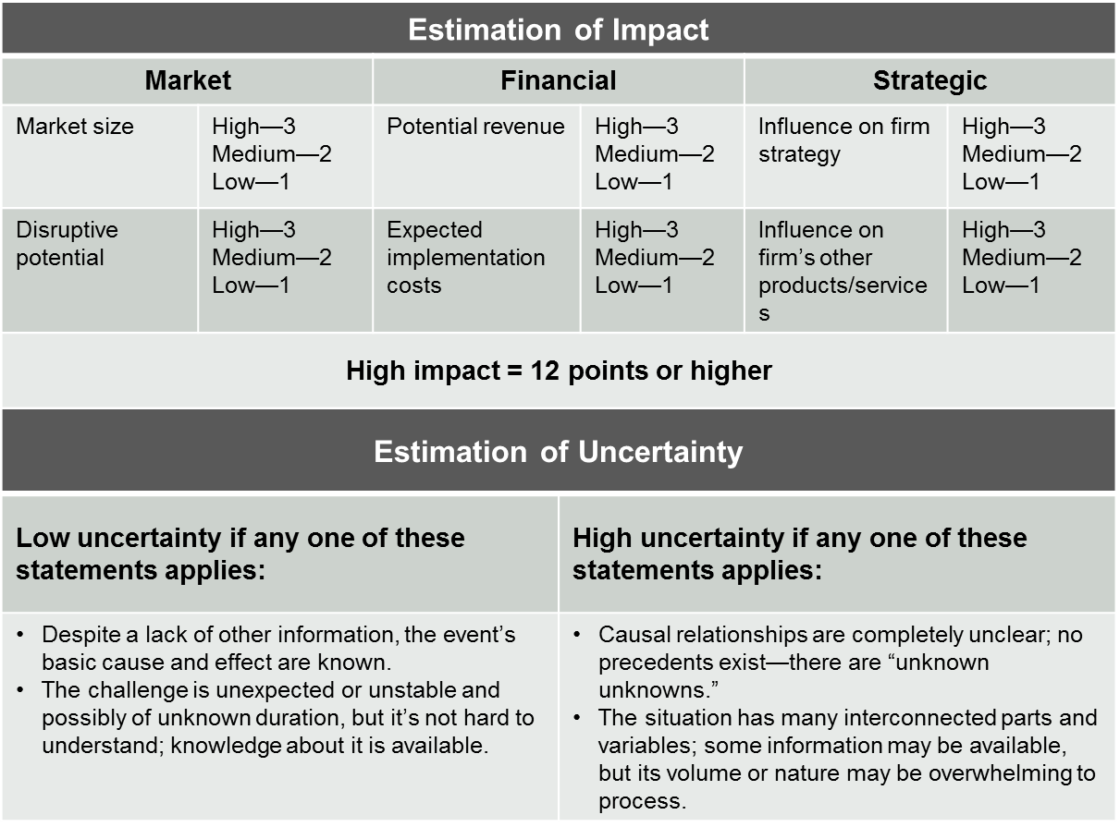
Figure 1: Rubric for assessing technology decisions
In the next step of our study, we engaged in in-depth case studies of 12 selected decisions from our sample, involving a range of enterprises (Table 1). All of the cases represent decisions that were regarded by those involved as having been handled effectively. Data were collected via semi structured interviews carried out with key innovation, R&D, and technology managers between 2012 and 2015. In the interviews, we asked about the strategies, objectives, tools, and criteria used to process the technology decision being examined. Together with the respondents, we assessed the decision with regard to the criteria for perceived impact and uncertainty, using our rubric.
Table 1.—Summary of cases
Case | Company Description | Employees (approx.) | Interviewee Roles | No. Interviews
Med_1 | Leading diagnostics and life sciences solution provider | 400 | Head of R&D  Head of innovation  R&D executive | 3
Med_2 | Leading manufacturer of artificial joint replacements and bone-graft substitutes | 400 | Head of innovation  Innovation manager | 2
Auto_1 | Global leader in automotive steering systems | 5,000 | Innovation manager  Head of technology  Division manager | 3
Auto_2 | Global leader in automotive acoustic and thermal management solutions | 9,600 | Head of R&D  Innovation manager  R&D manager | 5
Auto_3 | Global leader in vehicle and mechanical engineering | 76,000 | Innovation/technology manager  Business development manager | 3
Auto_4 | Automobile manufacturer | 50,000 | Innovation manager | 2
Elec_1 | Global leader for quality control devices | 500 | Head of R&D  R&D team leader | 4
Elec_2 | Manufacturer of electrical and optical connection technology | 3,500 | R&D executive | 3
Engi_1 | Manufacturer of vertical transportation solutions | 50,000 | Chief Technology Officer | 1
Engi_2 | Global mechanical engineering company | 54,000 | Head of product development  Innovation manager | 3
HomAp_1 | Global manufacturer of home appliances | 45,000 | R&D manager  Innovation manager | 3
Chem_1 | Global chemical company | >50,000 | R&D manager  Innovation manager | 7

Cases: Types of Technology Decisions
Analysis of workshop data resulted in a two-by-two matrix that classifies decisions by their level of impact and associated uncertainty (Figure 2). Each decision type has particular contextual factors that suggest specific methods and criteria, as well as an overall strategy, for the processing of the decision.
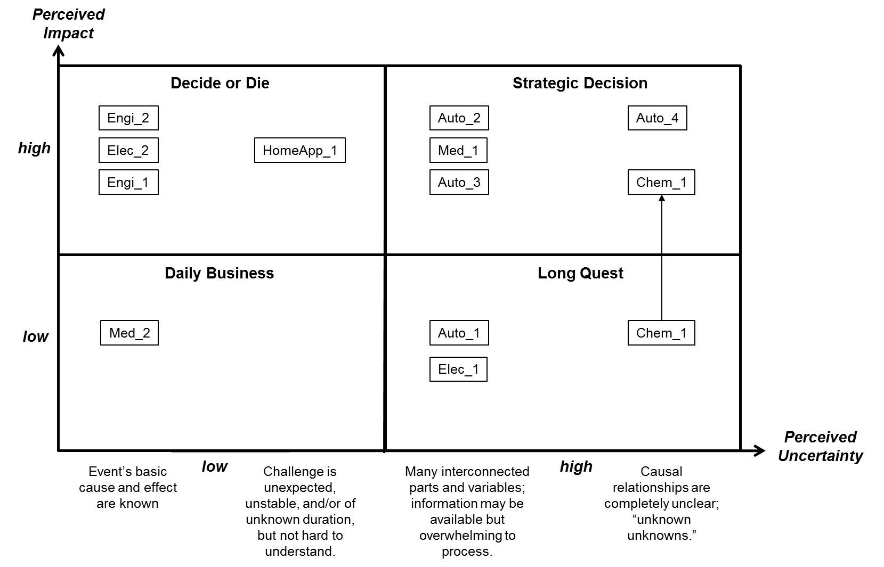
Figure 2.—Technology decision types

Daily Business: Low Impact, Low Uncertainty
In situations where the technology has both a low perceived impact and a low degree of uncertainty, the decision is neither particularly weighty nor particularly difficult, allowing for fast and easy decision making with minimal investigation. We call this type Daily Business, because it can be easily accommodated within the firm’s regular processes.
The company in Med_2 faced such a decision in the early 2000s, when a new technology became available that enabled cheaper production than the established industry-standard technology the company had been using, without significant switching costs. The effects of the decision could be easily predicted, as the switching process was fairly well known. For this reason, decision criteria were mostly based on quantitative data, such as return on investment (ROI) and time to payoff. As one of the managers involved said, “It was all about the costs and time-to-market.” The decision to adopt that technology required minimal time and effort from a lower-level manager; the management board was responsible only for confirming the decision based on information provided by managers.
There is an important caveat to this case, though. Although the decision process was implemented well from the perspective of those involved, the ease of the decision combined with a number of organizational factors led to a significant underestimation of the effort involved in implementing the decision. As a result, the decision was not well communicated and the implementation team was not well selected. According to the responsible R&D group leader, “The communication of the decision failed. The informed group of employees was too small, and the team assigned for the subsequent implementation was not that well diversified and therefore did not incorporate sufficiently diversified knowledge.” As a result, the team overlooked or underestimated the importance of many challenges in the implementation process and the implementation was delayed for a full year. This case demonstrates that while it may be comparatively easy to arrive at a decision of this type, careful attention must still be given to the implementation plan to ensure a successful implementation of the decision.
Daily Business decisions should be processed quickly and with low effort. Simple quantitative methods and criteria are sufficient, and higher-level decision makers need not necessarily be involved. However, managers should develop an appropriate execution and implementation plan to support the decision.

Decide or Die: High Impact, Low Uncertainty
In situations where the technology has a high perceived impact but a low degree of uncertainty, firms must react quickly, because the combination of low uncertainty and high impact means that other firms are likely to follow, and barriers to doing so are low. Because decision speed and decision quality are both vitally important in this quadrant, we call this type Decide or Die.
The firm in case Elec_2, a manufacturer of electrical and optical connection technology, was confronted with such a situation. In this case, a supplier had developed and brought to market a new manufacturing technology that decreased the time required for production by a factor of 10–20. While the new technology offered significant advantages in terms of the time and cost of production, integrating it into the existing manufacturing process required substantial investment. The combination of low uncertainty and easy accessibility for competitors made a quick decision important, but the technology´s anticipated high impact on the business required comprehensive evaluation and decision, creating an urgent need for both effectiveness and efficiency in decision making.
Because of the low level of uncertainty, the firm invested only marginally in information gathering, instead investing substantial time and resources to perform a thorough analysis of the likely impact of the final decision and to gain top-management attention and build broad acceptance for the technology in case of its implementation. With this in mind, the process included high-level decision makers (the CEO and CTO) and all middle- to high-level executives who would be affected by the technology. Ultimately, the management team decided to implement the technology, and the acceptance of the decision among stakeholders ensured a successful implementation.
Similar approaches were adopted by the firms in Engi_2 and HomAp_1 when they faced analogous decisions. Both firms involved in the analysis and decision making all internal stakeholders who would likely be affected by the technology, including R&D and production executives, the top management team, and the heads of sales and purchasing. These firms also reached outside for help when decisions could not be made internally. In Engi_2, for instance, internal resource constraints—specifically a lack of needed expertise—hampered the firm’s decision-making capability; the management team addressed this gap by including external technology and market experts in the analysis. The firm had to balance the potential negative consequences of including external help, such as knowledge spillovers and secrecy issues, against the value of the external contributors’ perspective in arriving at a decision and creating organizational support for its implementation. Ultimately, managers decided that the benefits of reaching a rapid decision were more important than the risks of sharing information externally.
In all cases of this type, case firms sought to make decisions on the basis of clearly defined criteria. The firms in Engi_2 and HomAp_1 had generated lists of possible criteria for general use; reviewing this list to select the criteria appropriate for a specific decision helped ensure all factors important to the firms were considered. Also, all firms used quantitative financial methods, such as net present value (NPV), ROI, time to payoff, discounted cash flow, and cost-benefit analysis, for decision support, in addition to qualitative methods such as Delphi, expert interviews, portfolio approaches, and core competency analysis.

Strategic Decision: High Impact, High Uncertainty
This field of the matrix represents the most challenging set of technology decisions. The high potential impact requires comprehensiveness and penalizes mistakes, and high uncertainty complicates the decision-making process. These are Strategic Decisions that profoundly influence firms’ future directions.
The firm in Auto_2 was forced to manage such a situation when a new software product developed for another industry had the potential to render existing products obsolete if the new software were transferred to the automotive industry. In another case, Med_1, the firm had the chance to adopt an early-stage technology that would enable completely new products for the diagnostics market; however, the market potential was not yet foreseeable, as the person responsible for the decision explained: “Proof of principle already existed but proof of market was not in sight.” Similarly, Auto_3 had the opportunity to exploit a new technology that could enable access to new markets in the aerospace industry.
In all of these cases, the ultimate goal of the decision was to quickly develop a reasonably comprehensive understanding of the technology´s potential and then select one of three options:
- Reject. The technology is not worthwhile or is too risky given the available information and overall situation; terminate the investigation.
- Wait and see. The technology is currently not of significant value but may become interesting in the future; monitor it and wait for the right moment to renew investigation. The goal, as the CTO of Auto_2 described it, is to “look at it, tell me what is happening—but don’t spend too many resources on it.”
- Repeat. The technology is relevant and promising; launch a new decision cycle to build on the insights gained in the previous cycle.
With options 2 and 3, the aim is to move the technology to the left side of the matrix—that is, to reduce uncertainty—based on increasing insight developed through repeated decision cycles. Throughout this decision process, underlying assumptions driving the decision and the assessment of the decision criteria must be documented to ensure the traceability of the decision and to preserve the information gained. Med_1 learned this lesson when its lack of documentation of previous decisions led to different teams investigating the same technologies several times. Additionally, all of our sample firms reported that they revisit rejected projects at regular intervals and start new decision cycles if the expected value of the technology changes, due either to further development of the technology or to external factors.
In all cases, the decision process involved technical and functional experts in information gathering and analysis and top management in final decision making. This was accomplished in a variety of ways. The firm in Auto_3 conducted one-day workshops with approximately 20 experts from all the relevant functional fields, with participants selected by the firm’s innovation managers. During these workshops, participants first defined potential target products and markets for the technology, then created scenarios and assumptions for each product/market combination and applied quantitative methods such as NPV, expected net present value (eNPV), decision trees, and ROI to analyze each scenario. These quantitative approaches allowed the market opportunities to be expressed in concrete figures despite the prevailing uncertainty. In deference to the high level of uncertainty, however, these calculations were considered only in combination with a clear definition of underlying assumptions regarding the technological, market, and regulatory context. Soft evaluation criteria, such as the technology’s fit with the firm’s strategy, technology S-curve, and technology portfolio, were also considered, as well as participants’ personal estimation of the risk involved.
It is particularly important, given the high uncertainty and potential impact of these decisions, to assure broad buy-in for these technologies and build top management support. The firm in case Auto_4 is particularly notable for its strong focus on communication around this type of technology decision. The company held a series of workshops involving important stakeholders to build broad backing and commitment for the technology within the firm,to explain the investments needed for the further development of the technology and to help stakeholders gain a better understanding of its potential applications.
The Strategic Decision archetype is particularly challenging for all involved. These decisions cannot be made in a simple process, nor can they be made too quickly. Instead, companies relied on iterative cycles of analysis and a combination of qualitative and quantitative methods supported by clearly defined and explicitly stated underlying assumptions.

Long Quest: High Uncertainty, Low Impact
High-uncertainty, low-impact technology decisions present a dilemma. On the one hand, given the low perceived impact, comparatively little effort should be devoted to these decisions. On the other hand, the high uncertainty makes it difficult to estimate whether a technology really is of little importance without expending significant resources. The ultimate goal of these cases is not to make an instant decision, but to gain a better understanding of the technology´s potential so that decision makers can either reject it or move it to one of the other quadrants of the model and launch an appropriate decision-making process. That process can take time and is almost impossible to plan, as information must be collected as it becomes available and sometimes the firm must wait for the technology to develop further. This is why we call this type of decision Long Quest.
The Auto_1 case provides an illustration of this circumstance. The firm in this case contemplated the introduction of carbon fiber in certain automotive components. The fiber would have slightly reduced the weight of the products but also added costs. At first, the technology’s impact was estimated to be low. Should a stronger trend toward lightweight construction develop, however, the fiber could become important for the company. In the case of Chem_1, the technology was initially estimated to have a minor impact. Accordingly, it was processed as a Long Quest decision. Based on the insights gained in the following investigations, however, the people involved came to the conclusion that the process should be reclassified as a Strategic Decision (see “Transitioning from Long Quest to Strategic Decision,” below).
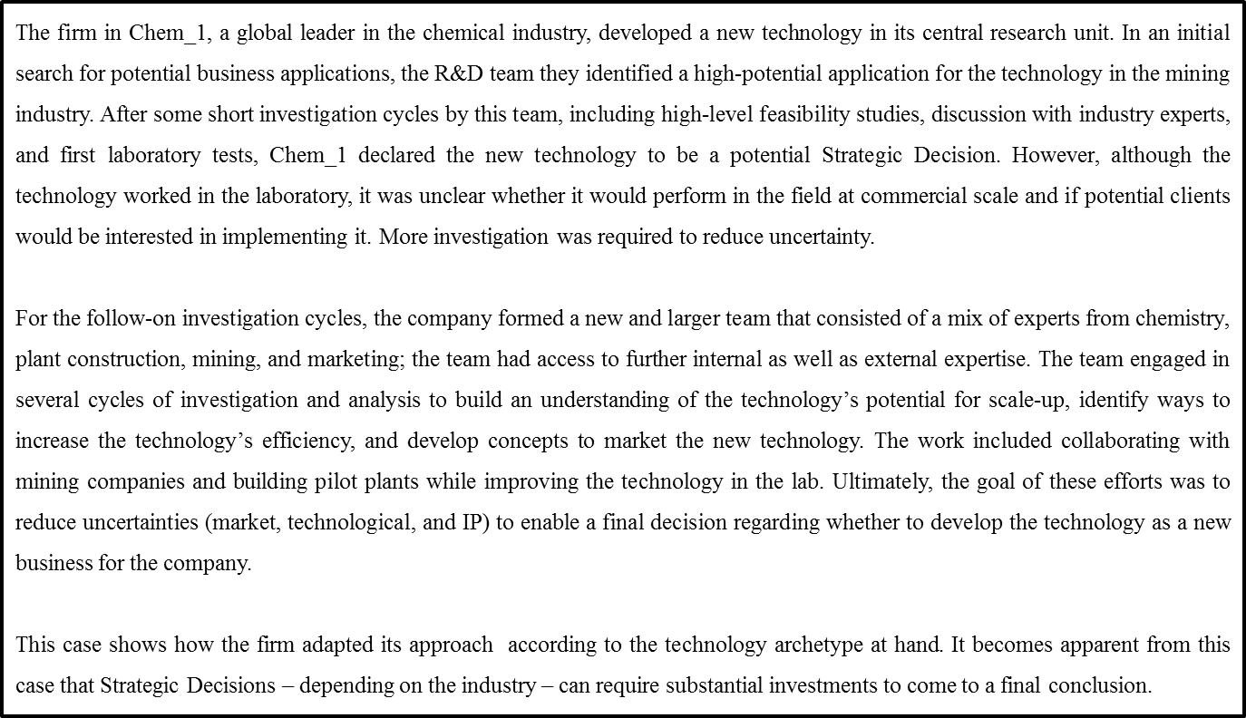
Text Box: Transitioning from Long Quest to Strategic Decision
To manage this trade-off, the firms in Auto_1 and Chem_1 conducted investigations in short iterative cycles, each lasting less than six months and involving mid-level employees, and each supported with as many resources as needed to assure a thorough investigation. The aim of each cycle was to develop an evidence base for subsequent reevaluations of the technology. In each cycle, prior to launching the investigation, the firm defined specific hypotheses about the potential value and impacts of the technology and made the underlying assumptions clear. This enabled the team to focus and accelerate succeeding investigations.
Each decision cycle included interviews with technology and market experts from within and outside the company, as well as desk research. At the close of the cycle, high-level R&D executives met to review the results and assess the technology using soft, qualitative criteria. No particular methods were used; stakeholders relied on their intuition and gut feeling. The iterative decision cycles reduced the uncertainty until management felt confident about making an investment decision.
Elec_2 and Med_1 used similar approaches in technology decisions of this type and assigned one person to be responsible for the information gathering. In the case of larger investigations, this project leader was allowed to select additional team members to provide support. Before initiating investigations, project leaders scheduled and coordinated the investigation with the head of R&D and defined binding dates and deliverables. This approach allocated responsibility for the investigation and avoided the problem of information gathering being disregarded in favor of other, more concrete projects with clear and direct returns for the company.
To get the most out of Long Quest investigations, it is important to assign highly motivated team members who are willing to search for relevant information, even if this search requires consistent effort over a comparatively long time. The firms in Med_1, Elec_2, and Med_2 typically delegated leadership of this process to the initiator of the technology decision or to the inventor of the technology, ensuring the dedication needed to proceed in this process. As in the Strategic Decision type, it is also important to document the underlying assumptions and the assessment of the decision criteria carefully, especially if the decision is to wait or repeat. Otherwise, as the firms in cases Elec_2 and Med_1 found, knowledge may be lost and effort duplicated.
It is also crucial to define clear termination criteria prior to launching the technology decision cycle. Without these hard boundaries, the company risks technologies becoming stuck in endless investigation cycles. This may happen when employees are particularly dedicated to certain technologies and want to avoid losing sunk costs. An R&D executive at the firm in case Elec_1 described the frustration of dealing with such a case: “At some point [after numerous cycles], we did not control the technology anymore but the technology controlled us.”

Discussion
In analyzing the cases, we found that each decision type had clear differentiating characteristics, in terms of the timeframe of the decision, the organizational level at which the decision was made, the type of criteria defined to guide the decision, and the methods used to support the decision (Figure 3). The major differentiator with regard to decision processes is in the level of uncertainty. In cases characterized by low uncertainty, firms attempted to process the technology decision and the subsequent implementation quickly. When confronted with low uncertainty and high impact, firms sought to achieve a comprehensive decision while working quickly, investing as many resources as necessary to achieve both thoroughness and rapidity. On the other hand, decisions around technologies with low uncertainty and low impact were regarded as less weighty, and therefore, there was greater tolerance for suboptimal decisions. In these cases, reducing resource inputs appeared to be more important than providing a comprehensive analysis to support the decision.
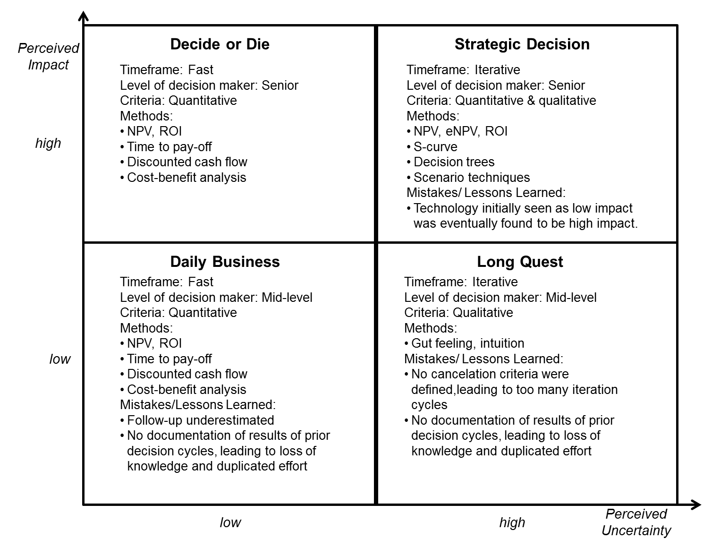
Figure 3: Overview on empirical findings
The tools used for both high- and low-impact decisions with low uncertainty were the same in all cases—typically, firms relied on quantitative methods for these fairly straightforward analyses. These methods were applied differently, however, with firms relying on rough calculations in low-impact decisions but creating far more thorough evaluations when the impact was expected to be greater and, therefore, a higher quality decision was required. Another useful tool in high-impact cases, illustrated by the cases of Engi_2 and HomAp_1, is a comprehensive, predefined list of criteria to guide evaluation and ensure that all relevant aspects of the technology and its potential market are considered. This was less important in low-impact decisions, where decisions tended to be made intuitively.
A final difference between the two low-uncertainty archetypes is the role of top management in decision making. In high-impact cases, firms emphasized the importance of gaining support for the technology being considered from all relevant stakeholders and especially from top management. These firms involved high-level stakeholders in the decision, including in analysis and decision making. For low-impact cases, on the other hand, high-level executives were involved only in the final decision making and in building commitment to the implementation of the decision. Analysis and information gathering in these cases was conducted by lower-level managers.
In both of these types, though, following up with a concrete action and communication plan for implementation—that is, for its integration into a product or production process—is critical, as illustrated by the Med_2 case, where failures in implementation led to significant delays and wasted resources in pursuit of a technology not seen as being particularly weighty for the company. With this in mind, firms should devote a substantial part of the analysis and decision-making process for these decisions to the development of a precise action plan, or at the very least, a risk management strategy that addresses potential obstacles in implementation.
High-uncertainty cases, by contrast, were processed completely differently from those seen as less uncertain. The ultimate goal in all of the high-uncertainty cases was not an instant implementation of the technology, but a reduction in uncertainty and thus in the risk associated with the decision. In all of the high-uncertainty cases, firms emphasized the importance of short, iterative decision cycles to gradually build insight and reduce uncertainty, with each cycle building a stronger estimation of the technology’s potential attractiveness and impact. If the decision at the end of an iteration is to reject, our data suggest two alternatives: reject or wait and see. If the technology is interesting but uncertainty remains too high or the impact is not clear, as in the cases of Auto_1, Auto_2, Auto_4, and Elec_2, the firm may decide to postpone the next decision cycle until new insights become available or the overall situation changes in a way that makes the technology more attractive.
The effort needed to collect information to support a decision to reject, wait, or repeat can be reduced if hypotheses about the technology’s value are made prior to the decision cycle. Establishing well-defined hypotheses allows for a focused search, one that seeks only the information needed to confirm or refute the hypothesis. Similarly, predefined termination criteria are important to ensure that decision cycles do not repeat endlessly. Moreover, as the cases of Elec_2 and Med_1 demonstrate, it may be beneficial to define deadlines and desired outcomes prior to the start of an investigation cycle.
There were some differences between high- and low-impact, high-uncertainty cases. In all of the high-impact cases, the firms invested as many resources as necessary to process the decisions as quickly and, most of all, as comprehensively as possible. Low-impact decisions, however, received a lower level of resource input because the lower potential for impact did not justify a large investment. Investigations were conducted by lower-level managers, with analysis and decision making done by middle managers. High-impact decisions, by contrast, required top management attention and the commitment of all relevant stakeholders, although information gathering was still performed by less senior staff.
Decision criteria for low-impact decisions were soft and qualitative; the high uncertainty impeded a quantitative evaluation and the low impact made it impractical to invest resources in more precise evaluations. Indeed, in these cases, decisions relied primarily on evaluators’ experience and intuition rather than on formalized methods. In higher-impact decisions, however, the firms sought to use quantitative tools in combination with qualitative methods.
Finally, in cases of high uncertainty, whatever the impact, thorough documentation of decision results is essential, to enable the future use of the knowledge gained and prevent duplicated effort.

Implications
Our case data suggest that technology decisions should be managed very differently depending primarily on the associated uncertainty and to a lesser degree on the potential impact. Classifying a technology decision along these axes before embarking on the decision-making process can help managers select an approach and allocate resources appropriately. One way to accomplish this is through a rubric that quantifies uncertainty and likely impact and places the decision in one of the four quadrants of our model.
That placement in the matrix of decision types suggests the appropriate strategy, criteria, and methods for approaching the decision (Table 2). Low-uncertainty, high-impact decisions—the Decide or Die quadrant in the matrix—require a quick but thorough decision-making process, while Daily Business decisions require quick action with a lower resource input. On the other hand, where uncertainty is high—whether impact is high or low—decisions must be based on more thorough, careful exploration intended to reduce uncertainty through iterative cycles. Indeed, the impact may not be clear at all until the uncertainty is reduced. Where the impact of the technology is judged to be low, short cycles with lower resource inputs will gradually lead to a better understanding of the technology that eventually allows it to be reclassified into one of the other archetypes; this is the Long Quest scenario. Where both uncertainty and impact are high, greater resources and more extended investigation is warranted; this is a Strategic Decision scenario.
Table 2.—Overview and managerial levers of technology decisions
Characteristic | Daily Business | Decide or Die | Strategic Decision | Long Quest
Basic strategy | - Quick decision-making  - Reduced resource input, minor deficiencies in rigor acceptable  - Concrete action and communication plan for implementation | - Quick decision making and action  - Comprehensive analysis  - Commitment of all stakeholders  - As much resource input as necessary (including external, if needed) | - Reduce uncertainty, make iterative decisions—reject, wait, repeat—as quickly as possible  - Management attention and commitment  - As much resource input as necessary (including external, if needed) | - Develop evaluation of impact and uncertainty, make iterative decisions—reject, wait, repeat  - Reduced resource input
Level of personnel involved | - Low for information gathering and analysis  - Middle to high for decision | - Low for information gathering  - Middle to high for analysis and decision | - Low to middle for information gathering  - High for analysis and decision | - Low for information gathering  - Medium for analysis and decision
Criteria | - Hard and quantitative  - Small set of criteria | - Hard and quantitative  - Soft criteria (e.g., strategic fit) included for accuracy and comprehensiveness | - As much quantitative as possible, always based on underlying assumptions  - Soft criteria (e.g., strategic fit) for completeness and accuracy | - Soft and qualitative with underlying assumptions
Methods | Quantitative  e.g., ROI, pay-off period, cost-benefit analysis | Quantitative  e.g., NPV, ROI, pay-off period, discounted cash flow, risk analysis, cost-benefit analysis  Qualitative  e.g., Delphi, expert interviews, portfolio approaches, core competency analysis | Quantitative  e.g., NPV, risk analysis, ROI, eNPV, decision trees  Qualitative  e.g., Scenario analysis; S-curve concept, core competency analysis, portfolios | Intuition, no specific methods applied

These insights, developed from our empirical data, can serve as structuring devices to ensure that technology decision-making processes are in line with the likely impact and uncertainty of the decision. In firms or business units without a defined technology decision-making process, the matrix of types and evaluation rubric can be used as ad hoc decision support to decide how to proceed for each technology. This is particularly helpful in units with responsibility for a wide range of technologies or in smaller firms whose processes are often not fully formalized. Our insights may also help practitioners gain a better understanding of the commonalities of and differences between the different types of technology decisions and the implications of each type for decision making. Furthermore, the classification framework and evaluation tools can help support discussion around technology decisions by providing a common language and a shared understanding of the bases for the decisions at hand.

Conclusion
Deciding which new technologies to invest in is a highly demanding and complex task that lays at the heart of any technology-based firm. With technology intensity increasing in most sectors, the significance of effective and efficient technology decision making will grow even more in future. While researchers and practitioners have developed many approaches to the decision-making processes, managers have had little assistance in determining which approaches are likely to work for any given decision. Our framework provides a tool to fill that gap, offering managers a method to determine the type of decision at hand and to choose a suitable approach for its processing. Ultimately, this tool will not only help firms to better allocate their resources but might also lead to better decisions.

References
Ajamian, G. M., and Koen, P. A. 2002. Technology Stage-Gate: A structured process for managing high risk new technology projects. In The PDMA Toolbook for New Product Development, ed. P. Beliveau, A. Griffin, and S. Somermeyer, 267–295. New York: Wiley.
Baum, J. R., and Wally, S. 2003. Strategic decision speed and ﬁrm performance. Strategic Management Journal 24:1107–1129.
Bennett, N., and Lemoine, J. 2014a. What VUCA really means for you. Harvard Business Review 92(1/2): 27.
Bennett, N., and Lemoine, J. 2014b. What a difference a word makes: Understanding threats to performance in a VUCA world. Business Horizons 57(3): 311–317.
Bitektine, A. 2008. Prospective case study design. Organizational Research Methods 11(1): 160–180.
Collins, H., Weinel, M., and Evans, R. 2010. The politics and policy of the Third Wave: New technologies and society. Critical Policy Studies 4(2): 185–201.
Collins, M., and Williams, L. 2014. A three-stage filter for effective technology selection. Research-Technology Management 57(3): 36–42.
Cooper, R. G. 2006. Managing technology development projects—Different than traditional development projects. Research-Technology Management 49(6): 23–31.
Corner, P. D., Kinicki, A. J. and Keats, B. W. 1994. Integrating organizational and individual information processing perspectives on choice. Organization Science 3:294–308.
Daim, T. U., and Kocaoglu, D. F. 2008. How do engineering managers evaluate technologies for acquisition? A review of the electronics industry. Engineering Management Journal 20(3): 44–52.
Farrukh, C., Dissel, M., Jackson, K., Phaal, R., and Probert, D. R. 2009. Valuing technology along a timeline of technological maturity. International Journal of Technology Management 48(1): 42–54.
Foden, J., and Berends, H. 2010. Technology management at Rolls-Royce. Research-Technology Management 53(2): 33–42.
Ford, S. J., Mortara, L., and Probert, D. R. 2012. Disentangling the complexity of early-stage technology acquisitions. Research-Technology Management 55(3): 40–48.
Horney, N., Pasmore, B., and O’Shea, T. 2010. Leadership agility: a business imperative for a VUCA world. Human Resource Planning 33(4): 34.
Hundley, G., Jacobson, C. K., and Park, S. H. 1996. Effects of profitability and liquidity on R&D intensity: Japanese and US companies compared. The Academy of Management Journal 39(6): 1659–1674.
Lin, B.-W., and Chen, J.-S. 2005. Corporate technology portfolios and R&D performance measures: A study of technology-intensive firms. R&D Management 35(2): 157–170.
Makri, M., Lane, P. J., and Gomez-Mejia, L.-R. 2006. CEO incentives, innovation, and performance in technology-intensive firms: A reconciliation of outcome and behavior-based incentive schemes. Strategic Management Journal 27(11): 1057–1080.
Mamer, J. W., and McCardle, K. F. 1987. Uncertainty, competition, and the adoption of new technology. Management Science 33(2): 161–177.
Markham, S. 2002. Moving technologies from lab to market. Research-Technology Management 45(6): 31–42.
Nutt, P. 1984. Types of organizational decision processes. Administrative Science Quarterly 29(2): 414–450.
Oliva, T. A. 1991. Information and profitability estimates: Modelling the firm's decision to adopt a new technology. Management Science 37(5): 607–623.
Palmié, M., Lingens, B., Gassmann, O. 2015. Towards an attention-based view of technology decisions. R&D Management. doi: 10.1111/radm.12146.
Paxson, D. A. 2001. Introduction to F&E real options. R&D Management 31(2): 109–113.
Rohrbeck, R., Heuer, J., and Arnold, H. 2006. The technology radar—An instrument of technology intelligence and innovation strategy. Proceedings of the 3rd IEEE International Conference on Management of Innovation and Technology, Singapore: Vol. 2, 978–983. IEEE.
Whitney, D. 2007. Assemble a technology development toolkit. Research-Technology Management 50(5): 52–58.
Whiteman, W.E. (1998). Training and educating army officers for the last 21st century: Implications for the United States Military Academy, Fort Belvoir, VA: Defense Technical Information Center.
Yin, R. K. 2014. Case Study Research: Design and Methods, 5th ed. Thousand Oaks, CA: Sage.

