Towards an Attention-based View of Technology Decisions
Blind for review

Abstract
The importance of technology decisions is widely acknowledged in both research and practice. However, we know little about how companies structure technology decisions from an organizational point of view and how attention is distributed in the course of the decision process in order to identify, process, and transfer information between the organizational units involved. Using the attention-based view of the firm and fourteen qualitative case studies, we present five approaches for organizing technology decisions: (1) Centralized Decision-Making, (2) Sedulous Information Bee, (3) Double-Blinded Analysis, (4) Moderated Expert Panel, and (5) Coterie Approach. On this ground, this paper introduces a new, attention-based view on technology decisions, which improves the theoretical understanding of organizations and provides guidelines for practitioners in choosing an appropriate organizational configuration in this regard.

Keywords: Technology decision, Attention-based View, organizational structures, uncertainty, decision-making structures

- Introduction
Within technology management, technology decisions are a substantial component and therefore subject of extensive research (Markman, Siegel and Wright, 2008; Farrukh, Dissel, Jackson, Phaal and Robert, 2009; Liao, 2001; Martinsuo & Poskela, 2011). Technology decisions cover three sub-tasks. The first sub-task is “information gathering” and embraces activities for the reduction of uncertainty of a technology. The following sub-task “analysis” looks into the integration and analysis of the gathered information and provides the foundation for the succeeding “decision”, the final sub-task (Ajamian & Koen, 2002; Cooper, 2006; 2008; Mamer & McCardle, 1987; McCardle, 1985; Oliva, 1991).
These sub-tasks are typically carried out by different employees and organizational units within a company (Ajamian & Koen, 2002; Cooper, 2006; 2008), so that information is produced and stored by individuals from different organizational units (Grant, 1996). This information provides the foundation for technology decisions (Mamer & McCardle, 1987; McCardle, 1985; Mintzberg, Rhisinghani and Théorêt, 1976; Nutt, 1984). To use this scattered information for decision-making, it needs to get transferred, unified, and processed. And this, in turn, typically requires that decision-makers become aware of and identify it as relevant, since they are unlikely to act on things that do not attract their attention (Ocasio, 1997; 2011; 2012). For this reason, the distribution of decision-makers attention across issues and answers becomes important (Ocasio, 1997; Joseph & Ocasio, 2012). Attention, however, is shaped by the organizational structure decision-makers find themselves in (Ocasio, 1997). Thus, the organizational structure of technology decisions is crucial for the distribution of attention among the units involved and, ultimately, for decision-making outcomes (Ocasio, 1997).
Nevertheless, technology decisions have not yet been extensively studied from an attention-based perspective. Moreover, there are very few studies dealing with organizational aspects of technology decisions. These works consider the entities involved in the sub-tasks of technology decisions and also their organizational integration (e. g. Bucher et al., 2003; Foden and Berends, 2010; Ho et al., 2011; Phaal et al., 2012), but do not regard the attention-based view (Ocasio, 1997). From an attention-based view, literature has analyzed various antecedents to attention (e.g., Bouquet and Birkinshaw, 2008; Cho and Hambrick, 2006; Dutton and Ashford, 1993; Hansen and Haas, 2001; Nadkarni and Barr, 2008), but has rarely covered organizational structures as such antecedents, even though this being a core argument of the initial outline of the attention-based view (Ocasio, 1997).
By addressing this gap, the purpose of this paper is to provide answers to three interrelated questions: How can firms organize technology decisions, how can they distribute decision-makers attention and how does the organization of technology decisions and distribution of attention differ across boundary conditions? To this end, we will develop a theoretical framework based on the attention-based view, which we enrich by insights derived from fourteen qualitative cases.
On this ground, our paper intends to make multiple contributions to the literature and to management practice. First of all, we introduce the attention-based view of the firm to the field of technology decisions and show that doing so yields crucial insights into technology decision-making and its outcomes. Secondly, we develop five organizational approaches and their contingencies as well as boundary conditions for the distribution of attention in the context of technology decisions. Thirdly, we show how attention might be distributed favorably depending on the decision situation at hand. Also, we state several propositions for future research along these lines which go beyond and extend our empirical insights. Additionally, we condense our results into dedicated practitioner guidelines. By this, our study complements, deepens and extends previous findings regarding the organization of technology decisions and the attention-based view of the firm.

- Literature Review
2.1 The attention-based view of the firm
Based on earlier work (Simon, 1947; March & Simon, 1958; Cyert & March, 1963; Weick, 1979; Cohen, March and Olsen, 1972), Ocasio (1997) describes an attention-based view of decision behavior in organizations. This view depicts firms as systems of structurally distributed attention. Attention is defined as “the noticing, encoding, interpreting, and focusing of time and effort” (Ocasio, 1997: 189) on issues and answers, which can be seen as information about the environment and available action alternatives (Ocasio, 1997). In essence, the attention-based view claims that actions of decision-makers and the subsequent organizational moves depend on which issues and answers they focus their attention on (Ocasio, 1997). This hinges on the specific situation and the context they are in (Ocasio, 1997; 2012; Ross & Nisbett, 1991).
2.2 The focusing and regulation of attention
The amount of attention a decision-maker can focus on issues and answers is finite (Simon, 1947). If decision-makers get confronted with more information than they can process, their attention becomes selective (Cyert & March, 1963; Mintzberg, 1973). Selective attention acts as a funnel, ensuring that people focus solely on certain issues and answers whilst others are blocked out (Fiol & O’Connor, 2003; Starbuck & Milliken, 1988). Only issues and answers that catch their attention will influence their actions (Simon, 1947). Consequently, selective focusing of attention permits the concentration of energy and effort on a limited set of issues and tasks, facilitating the speed and accuracy of decision-makers perception and action (Ocasio, 1997). On the downside, selective focusing of attention can also lead to a potential neglect of relevant options, information and decision alternatives (Barnett, 2008; McNamara & Bromiley, 1999; Yates, Jagacinski & Faber, 1978).
The focus of attention is affected by so-called communication and procedural channels (Ocasio, 1997). These channels can be described according to their spatial, temporal and procedural dimensions. They comprise formal and informal activities, interactions and communications, which focus decision-makers´ attention on certain issues and answers (Ocasio, 1997; Ocasio and Joseph, 2005; Stinchcombe, 1968). Communication channels can take the form of meetings, gatherings, workshops, conferences as well as written, verbal and technological forms of interaction between participants (Joseph & Ocasio, 2012; Ocasio, 1997). Within a channel, attention is either focused by passive reactions to environmental stimuli or active preparation and concentration of effort and energy. The importance of issues and answers and the interest of decision-makers stimulate active preparation and concentration, which enhances speed and accuracy of decision-makers´ perception and action (Ocasio, 1997).
Besides the focus of attention, another important facet of attention distribution is the regulation of attention. This facet acknowledges that firms can actively regulate decision-makers´ attention by setting organizational rules and allocating specific tasks among persons or groups of persons (Ocasio, 1997). When firms possess flexible organizational structures, they can typically regulate decision-makers´ attention flexibly. Flexibility of attention regulation helps decision-makers to switch easily from specific issues and answers to others, should it seem appropriate (Ocasio, 1997).
Altogether, the attention-based view highlights the following aspects, which are relevant for the further development of an attention-based view of technology decisions:
- The distribution of decision-makers´ attention is dependent on the characteristics of the communication and procedural channels (e.g. the number and function of persons involved in this channel).
- The channels´ spatial, temporal and procedural dimension affects decision-makers’ focus of attention.
- When it comes to the focusing and regulation of attention, there could be a trade-off between speed and accuracy of decision-makers´ perception and action and the comprehensiveness of issues and answers considered.
- Regulation of attention is affected by the flexibility of organizational structures.
- Methods
Our research uses a multi-case study design (Punch, 2005; Yin, 2009; 2014), which is ideal if a phenomenon is little known, existing aspects are incomplete or fragmented or a new perspective on an already researched topic is needed (Eisenhardt, 1989). Since we aim to include a new perspective on technology decisions, we view an explorative multi case-study as a suitable methodology.
All 14 cases we use are based on semi-structured interviews carried out between 2012 and 2014. We selected European enterprises of technology-intensive industries (engineering, chemistry, automotive, machine building, medical engineering and electronics). This sample embraces both large and leading companies as well as small firms to achieve a broad sample, which ensures the generalizability of our contribution A description of the companies and their respective cases is displayed in Table 1.
<< Insert Table 1 about here >>
The collection of the data took place in two phases, whereby mutual adjustments between data collection and analysis were possible (Eisenhardt, 1989). In the first phase, an interview at each company was conducted with the employee that was named as the main reference person for technology decisions. The interview comprised of broad and open questions. Respondents had to answer a questionnaire which covered, among others, three principal questions: (1) What does the process of technology decisions look like, (2) who is involved (3) and what are the respective tasks of the employees involved. A more detailed interview guideline for stage one can be found in the Appendix. Visualizations such as process flow diagrams were created and validated with the respondents. The data were complemented and triangulated through an analysis of media reports (internet research), company publications (internal newsletters, innovation briefs) and presentations (organization charts, project summaries). The data of stage one were processed with an open mind and without predefined propositions and were summarized into small case studies presenting the process of technology decisions, the persons involved and their respective tasks. We also described with whom the actors involved communicate in the context of technology decisions. These small cases were supplemented with a literature review about technology decisions and the attention-based view, which serves as basis for a conceptual framework that displays our key concepts and their causal relationships. This was the starting point for a deeper analysis, conducted in stage two (Eisenhardt, 1989).
In stage two, we applied a semi-structured interview guideline based on the conceptual framework which we developed in phase one and additional aspects of the attention-based view as defined at the end of our literature review. This theoretical framework was used in order to “determin[e] the data to collect and the strategies for analyzing the data” (Yin, 2014: 38). Open questions allowed the respondents to speak freely and provide additional information. We executed one to five in-depth interviews per case, which took between 30 and 60 minutes (Ø 50 minutes). The respondents were heads of innovation, project managers, R&D- and technology managers, heads of business units and chief technology officers. Respondents were also asked to recommend colleagues who were involved in technology decisions and could give additional information for validation (Denzin & Lincoln, 1994; Gibbert, Ruigrok and Wicki, 2008). We had between two and eight follow-up interviews per company. For a more detailed description of the interviews, please see Table 1. During the execution of all interviews, we constantly improved the questionnaire with new insights gained from the interviews.
All interviews, except four, were recorded on tape and transcribed afterwards. We made detailed notes and completed interview protocols immediately for interviews that we were not able to record on tape. All information were independently coded and analyzed by the authors (Mayring, 2007). This was done without additional coding software, as our theoretical framework provided us with patterns of expected results as well as a guideline for analyzing the data (Yin, 2014). Therefore we could easily identify constructs under consideration. We did not mention any element of our emergent theoretical insights to the interviewees to control for potential respondent bias. To diminish recall and rationalization bias and to enhance the consistency of our results, we triangulated our collected interview data with internal company data sources like organization charts, presentations and memos (Davis and Eisenhardt, 2011). We got full access to these data sources but had to confirm not to display any confidential information in this paper in return (Gilbert, 2006). The resulting cases were summarized into detailed documentations and sent to the respondents for a final proof of correctness in order to avoid single-respondent bias.
Generally, we arranged the data analysis iteratively with feedback between the data and emerging themes (Miles & Huberman, 1994; Locke, 2001). Every statement was paraphrased and compared to gain a better understanding of how the respondents saw the world (Locke, 2001). Statements of the respondents were arranged based on the identified variables from phase one. The results were compared through a cross-case analysis (Eisenhardt, 1989). This holistic and embedded approach allowed an in-depth view of the research subject and the deduction of general practices (Yin, 2009).

- Findings
Based on our literature review, we built an attention-based framework of technology decisions, which covers two aspects. Firstly, we follow Ocasio´s (1997) reasoning and use “focus of attention” as an expression for the number of players, i.e. organizational departments or persons involved in a particular communication or procedural channel. We define a broader focus of attention if many and very different units and functions are involved. On the contrary, involving just a few departments and functions implies a smaller focus of attention. Table 2 provides a detailed overview of organizational units and people involved in the technology decisions, which are described by our cases. Secondly, “regulation of attention” serves as an expression whether attention is distributed and allocated with a flexible or inflexible organizational approach. The incorporation of our cases into these categories is shown in Figure 1. Based on this framework, we subsume our cases under five basic approaches for attention distribution, which are described in the following.
<< Insert Figure 1 about here >>
<< Insert Table 2 about here >>
Centralized Decision-Making (Cases C, E, F, K, L)
<< Insert Figure 2 about here >>
The cases C, E, F, K, and L represent the archetype of centralized decision-making. In all of these cases, several departments assigned with the sub-task information gathering send their respective heads to a committee, which meets regularly. The participants perform the analysis together whereby each of them contributes the information gathered in his/ her scope. In the cases E, F, K, and L, the decision is made unanimously by all participants, which often leads to very long discussions until a consensual decision is reached. In case C, the decision is made solely by one participant of the meeting. In all cases, the departments responsible for information gathering and, consequently, the participants of the decision-making committee are permanently defined. Table 2 provides a detailed overview of the organizational units involved and their respective tasks. Additionally, case E is displayed in Figure 2. In all firms, centralized decision-making is solely applied for technologies that are regarded as less uncertain. In case E, F, and L, the archetype is used for technologies with a high as well as minor perceived impact on the firm. In case C and K, solely technologies with lower perceived impact are processed.
Coterie Approach (Case A)
Case A describes an approach which the respective firm is using for technology decisions being initiated by the CTO or the head of product development. In this case, both managers are equally responsible for information gathering, analysis and decision. The information used for this purpose is mainly sourced from the managers´ personal experience. Consequently, the effort is low and this approach is solely used for decisions with relatively low perceived uncertainty and impact of the respective technology. Since most employees of the respective firm are located at the headquarters, both decision-makers are well connected within the company and can easily obtain information outside the technology decision committee through informal meetings and spontaneous encounters with colleagues.
Sedulous Information Bee (Case B, M, N,)
The cases B, M, and N describe the sedulous information bee. In this archetype, one person, e.g. the innovation manager, is assigned with the sub-task information gathering. He/ she situationally selects other employees and internal as well as external experts in order to gather information. In case M and N, this person is supported by fellow co-workers. Subsequently, he/ she presents these information to a small group of people, who perform the analysis and decision together. This approach is solely used for decisions on early-stage technologies with a relatively low perceived impact and a high uncertainty. Because of the latter, information gathering and analysis are done in an iterative fashion, with alternation between the definition of potentially relevant applications of the technology and collection of related information. These iterative cycles are conducted over a relatively long time span since technology decisions are just a side-project for the employees involved in addition to their everyday work. However, in case M and N, the people who conduct the information gathering are typically provided with more budget and time for additional in-depth investigations if a technology at stake appears to have a higher impact than estimated at the start of the decision process. In these cases, therefore, the companies do not switch to organizational approaches that are normally used to process technologies with comparatively high perceived impact. The people involved in the decision process in all three cases are displayed by Table 2. Moreover, case N is displayed in Figure 3.
<< Insert Figure 3 about here >>
Moderated Expert Panel (Case D, H, I, J)
The moderated expert panel, which is represented by the cases B, H, I, and J, is very time-consuming and laborious. Consequently, it is used for technologies with relatively high perceived impact and uncertainty only. In all cases, one or few persons, typically innovation or technology managers, select internal as well as external experts and employees, usually approx. 20 people. These people are situationally chosen, since they are expected to have information regarding the technology at hand. They conduct a workshop together, moderated by the organizer, in which information are exchanged and the analysis is performed. In the cases H, I and J, one central workshop is carried out, whilst in case D, several decentralized workshops with several organization units of the firm are conducted. Case D is also displayed in Figure 4. In cases I and D, the decision is made by one person, who is not involved in the workshops. In all other cases, a group decision is made in which all participants of the workshop are involved. The people involved in the decision process are displayed in Table 2.
<< Insert Figure 4 about here >>
Double-Blinded Analysis (Case G)
<< Insert Figure 5 about here >>
In Case G (displayed in Figure 5), several employees (see Table 2 for an overview) are involved with the sub-task of information gathering. Each of the associated departments collects information in its specific field and dispatches one employee each, usually the head of department, to a committee meeting in which the analysis is executed. One participant of the committee presents the results to the decision-maker, who does not take part in the committee. In case of higher perceived uncertainty, the decision-maker orders the innovation manager to collect additional information. To this end, the innovation manager selects additional experts and employees on a situational basis and acquires further information about the technology. On this ground, the final decision is made. This approach is typically used for technologies with high perceived impact.
- Results, Discussion and Propositions
In this section, we discuss our empirical findings with special consideration of the aspects which are displayed at the end of our literature review. On this ground, we develop six propositions, which condense and also extend our empirical insights.
5.1 Regulation of attention depending on perceived uncertainty
<< Insert Figure 6 about here >>
Centralized Decision-Making and the Coterie Approach induce an inflexible regulation of attention. As our cases and Figure 6 illustrate, these approaches were only used if the respective technology was characterized by relatively low uncertainty. In contrast, for decisions concerning technologies with comparably high perceived uncertainty, only approaches with a flexible structural regulation of attention were applied. Ocasio’s (1997) distinction between decision-makers´ preparatory attention and their passive reaction to environmental stimuli provides a foundation to explain this observation. Following his line of reasoning, a higher degree of uncertainty makes it difficult to define the focus of attention ex ante; the unpredictability of the situation impedes such preparatory attention (Ocasio, 1997). In these situations, a flexible organizational structure seems to be a solution. This permits focusing of attention in an iterative fashion as a succession of responses to environmental stimuli and the following alignment of attentional structures on identified issues and answers. By this, the danger that decision-makers overlook potentially relevant issues and answers might be reduced, even in situations characterized by relatively high uncertainty. This is important, since the neglect of crucial issues and answers leads to the disregard of potentially relevant options (Das and Teng, 1999), biased decisions (McNamara and Bromiley, 1999) and rejection of valuable decision alternatives (Yates, Jagacinski and Faber, 1978). However, in situations of lower uncertainty, preparatory attention can define and fix the focus of attention ex ante. This enhances speed and accuracy of decision-makers´ perception and action (Ocasio, 1997). These notions lead to the following propositions:
Proposition 1: In situations of relatively low uncertainty, regulating decision-makers’ attention with inflexible structures improves the speed and accuracy of decision-makers´ perception and action. In situations of relatively high uncertainty, regulation of attention with flexible structures reduces the possibility to overlook potentially relevant issues and answers.
Proposition 2: In situations of relatively low uncertainty, enhancing the speed and accuracy of decision-makers´ perception and action is favorable. In situations of relatively high uncertainty, reducing the possibility to overlook potentially relevant issues and answers is preferable.
As an addition to this reasoning, a differentiation between fundamental forms of uncertainty, provided by some work in the field of evolutionary economics (e. g. Dosi and Egidi, 1991; Loasby, 2003; Metcalfe, 1994; Nelson and Consoli, 2010) could be applied. From this perspective, “substantive uncertainty” describes a decision situation in which decision-makers are basically able to understand the situation but suffer from an incomplete set of information (Dosi and Egidi, 1991). In such a situation, preparatory attention (Ocasio, 1997) might be possible. By contrast, in situations of “procedural uncertainty”, people are unable to recognize relevant information, even when available, due to a lack of problem-solving competence (Dosi and Egidi, 1991). From Ocasio´s (1997) standpoint, preparatory attention might not be applied in such a situation, since the decision-maker is unable to identify the issues and answers s/he should focus his/ her attention on ex ante. This reasoning leads to the following propositions:
Proposition 3: In situations of substantive uncertainty, regulating decision-makers’ attention with inflexible structures enhances the speed and accuracy of decision-makers´ perception and action. In situations of procedural uncertainty, regulation of attention with flexible structures reduces the possibility to overlook potentially relevant issues and answers.
Proposition 4: In situations of substantive uncertainty, enhancing the speed and accuracy of decision-makers´ perception and action is favorable. In situations of procedural uncertainty, reducing the possibility to overlook potentially relevant issues and answers is preferable.

5.2 Focusing of attention depending on perceived impact
<< Insert Figure 7 about here >>
Besides uncertainty, our cases also display the perceived impact of the technologies which were the subject of a decision organized in a specific way. Perceived impact refers to the technology´s significance for the company that persons involved in decision-making attributed to it when shaping the organizational structure of the decision.
As our cases and Figure 7 display, approaches inducing a broader focus of attention were mainly used to process technologies with a relatively high level of perceived impact. This is an interesting aspect given the insights of prior research about a manager’s exposure to alternatives. Because decision-makers concentrate their attention on just a few issues and answers, they focus on limited targets and expose themselves to a small set of alternatives only (Ocasio, 1997). As outlined above, this can lead to the neglect of potentially valuable decision options, biased decisions, and rejection of valuable decision alternatives (Das and Teng, 1999; McNamara and Bromiley, 1999; Yates, Jagacinski and Faber, 1978). From this perspective, a broader focus of attention can be a means to overcome these problems since it ensures decision-maker’s exposure to a large set of issues and answers. In the case of technologies with comparatively low perceived impact, however, our cases display a preference for smaller foci of attention. As Ocasio (1997) notes, the thereby exhibited concentration of attention enhances speed and accuracy of decision-makers´ perception and action for those activities attended to (Ocasio, 1997). This reasoning leads to the following proposition:
Proposition 5: In case of decisions with a relatively low perceived impact, speed and accuracy of decision-makers´ perception and action tend to be more important than the danger to overlook potentially relevant issues and answers. In case of decisions with a relatively high level of perceived impact, it is more important to reduce the danger to overlook potentially relevant issues and answers than to enhance the speed and accuracy of decision-makers´ perception and action.
Additionally, our cases display some notable deviations from these propositions. First, in some instances, such as case E, F, and L, approaches causing broader focus of attention were applied for technologies with lower perceived impact as well. On first glance, this seems to contradict the proposition we stated above, according to which a broader focus of attention tends to be less appropriate for low-impact technologies. However, it is interesting to notice that in the instances in which firms deviate from this general rule, they tend to rely on regular meetings with a fixed set of people involved and a clearly defined agenda, formal structures and voting rules. Following Ocasio (1997), these aspects can be described as the channels’ procedural dimension, which permits focusing decision-makers’ attention to the relevant issues and answers addressed in this meeting. Hence, despite of the large number of people involved, these procedural dimensions of the regular meeting seemingly allow for an efficient processing of low-impact technologies, too.
Second, the cases M and N show another interesting aspect. In line with our propositions, the companies normally use approaches with smaller focus of attention for low-impact technologies only. In some situations, however, they start decision-making processes for a technology which is estimated as highly uncertain and not very important. Nevertheless, in the course of the decision processes, it might become apparent that the technology is very significant. Instead of switching to an organizational setting which permits a broader focus of attention, the companies often stick to the current approach and the same team responsible for decision-making. Thus, the skills, knowledge and experience these persons have gained so far continue to benefit the subsequent decision-making process. Apparently, this aspect is of higher importance than the application of an organizational approach which would be more suitable from the standpoint of attention distribution. This leads to the last proposition:
Proposition 6: Besides perceived uncertainty and impact of the technology, the availability and form of skilled labor is an important antecedent to the choice of organizational approaches and, therefore, for the distribution of attention.
6. Implications and Conclusion
The quality of technology decisions is dependent on the transfer of information between organizational units involved in the decision (Mintzberg et al., 1976; Nutt, 1984). For this purpose, organizational structures must distribute decision-makers´ attention appropriately among issues and answers (Ocasio, 1997; Joseph & Ocasio, 2012). Following this reasoning, our paper introduces an attention-based (Ocasio, 1997) framework of technology decisions, which comprises the two characteristics focus of attention and regulation of attention. We enrich and deepen this framework with insights derived from fourteen cases.
On these grounds, we define five approaches for organizing technology decisions and, consequently, distribution of attention. These approaches are (1) Centralized Decision-Making, (2) Coterie Approach, (3) Sedulous Information Bee, (4) Double-Blinded Analysis, and (5) Moderated Expert Panel. Additionally, we sharpen these insights and discuss potential boundary conditions and contingencies of the approaches, leading to six propositions. Based on our Propositions 1, 2 and 5, Figure 8 displays our recommendations concerning the application of the approaches in business practice.
<< Insert Figure 8 about here >>
In a situation of relatively low perceived uncertainty, inflexible organizational approaches like the Coterie Approach or Centralized Decision-Making are appropriate. The first should only be used for low-impact technologies. The latter is also applicable for technologies with comparably high perceived impact. If a technology is characterized by relatively high perceived uncertainty, flexible organizational approaches such as Sedulous Information Bee, Moderated Expert Panel or Double-Blinded Analysis are needed. In the case of a technology with relatively low perceived impact, the Sedulous Information Bee is recommended, whereas comparatively high perceived impact requires the Moderated Expert Panel or the Double-Blinded Analysis.
In our third and fourth proposition, we discuss the differentiation between substantive and procedural uncertainty and include the perspective of evolutionary economics (e. g. Dosi and Egidi, 1991; Loasby, 2003; Metcalfe, 1994; Nelson and Consoli, 2010) in our paper. The connection between this field and the attention-based view, however, is not a major focus of our paper albeit it seems to be a very interesting field of research. Hence, we would like to encourage further investigations along these lines. Our last proposition highlights the importance of skilled labor as an antecedent to attention distribution. Based on our cases, we are not able to delve deeper into this issue. People’s skills usually have a considerable influence on their ability to process information (Kanfer and Ackerman, 1989). Given that the quality and outcomes of decision-making depend substantially on information (Mamer & McCardle, 1987; Mintzberg et al., 1976; Nutt, 1984), the intersection of skilled labor, organizational structures and the distribution of attention in the context of technology decisions presents a promising path for future research. Future research can also address the limitation of our work, which is due to our reliance on a purely qualitative research design: We cannot validate our propositions statistically. Future studies should apply large-scale samples to test the accuracy and generalizability of our findings.
In general, our paper is one of the very few works concerning organizational antecedents of attention. Additionally, and as far as we know, it is also one of the first steps towards an attention-based view of technology decisions. Therefore, it is our hope that this paper sparks further research about the implications of Ocasio’s intriguing theory for technology and innovation management.
7. References
Ajamian, G. M., & Koen, P. A. (2002). Technology-Stage-Gate: A Structured Process for Managing High-Risk New Technology Projects. In P. Beliveau, A. Griffin, & S. Somermeyer (Eds.), The PDMA Toolbook for New Product Development (pp. 267-295). New York: Wiley.
Barnett, M. L. (2008). An Attention-Based View of Real Options Reasoning. Academy of Management Review, 33(3), 606-628.
Bouquet, C., & Birkinshaw, J. (2008). Weight versus Voice: How Foreign Subsidiaries Gain Attention From Corporate Headquarters. Academy of Management Journal, 51(3), 577–601.

Bucher, P., Birkenmeier, B., Brodbeck, H., & Escher, J.-P. (2003). Management principles for evaluating and introducing disruptive technologies: the case of nanotechnology in Switzerland. R&D Management, 33(2), 149-164.
Cohen, M. D., March J. G., & Olsen, J. P. (1972). A Garbage Can Model of Organizational Choice. Administrative Science Quarterly, 17(1), 1-25.
Cooper, R. G. (2006). Managing Technology Development Projects – Different Than Traditional Development Projects. Research-Technology Management, 49(6), 23-31.
Cooper, R. G. (2008). Perspective: The Stage-Gate Idea-to-Launch Process – Update, What’s New, and NexGen Systems. Journal of Product Innovation Management, 25(3), 213-232.
Cho, T. S., & Hambrick, D.C. (2006). Attention as the Mediator Between Top Management Team Characteristics and Strategic Change: The Case of Airline Deregulation. Organization Science, 17(4), 453–469.
Dosi, G., & Egidi, M. (1991). Substantive and Procedural Uncertainty: An Exploration of Economic Behaviours in Changing Environments. Journal of Evolutionary Economics, 1(2), 145-168.
Cyert, R. M., & March, J. G. (1963). A Behavioral Theory of the Firm. Englewood Cliffs, NJ: Prentice-Hall/ Pearson Education.
Das, T. K., & Teng, B.-S. (1999). Cognitive Biases and Strategic Decision Processes: An Integrative Perspective. Journal of Management Studies, 36(6), 757-778.
Davis, J. P., & Eisenhardt, K. M. (2011). Rotating leadership and symbiotic organization: relationship processes in the context of collaborative innovation. Administrative Science Quarterly, 56(2), 159-201.
Denzin, N. K., & Lincoln, Y. S. (1994). Handbook of Qualitative Research. Thousand Oaks, CA: Sage Publications.
Dutton, J. E., & Ashford, S. J. (1993). Selling Issues to Top Management. Academy of Management Review, 18(3), 397–428.
Eisenhardt, K. M. (1989). Building Theories from Case Study Research. Academy of Management Review, 14(4), 532–550.
Farrukh, C., Dissel, M., Jackson, K., Phaal, R., & Probert, D. R. (2009). Valuing technology along a timeline of technological maturity. International Journal of Technology Management, 48(1), 42-55.
Fiol, C. M., & O’Connor, E. J. (2003). Waking up! Mindfulness in the Face of Bandwagons. Academy of Management Review, 28(1), 54-70.
Foden, J., & Berends, H. (2010). Technology Management at Rolls-Royce. Research Technology Management, 53(2), 33-42.
Grant, R. M. (1996). Prospering in Dynamically-Competitive Environments: Organizational Capability as Knowledge Integration. Organization Science, 7(4), 375-387.
Gibbert, M., Ruigrok, W., & Wicki, B. (2008). What passes as a rigorous case study? Strategic Management Journal, 29(13), 1465–1474.
Gilbert, C. G. (2006). Change in the presence of residual fit: Can competing frames coexist? Organization Science, 17(1), 150-167.
Hansen, M. T, & Haas, M. R. (2001). Competing for Attention in Knowledge Markets: Electronic Document Dissemination in a Management Consulting Company. Administrative Science Quarterly, 46(1): 1–28.
Joseph, J.; Ocasio, W. (2012). Architecture, attention, and adaptation in the multibusiness firm: General electric from 1951 to 2001. Strategic Management Journal, 33(6), Jun, 2012.
Kanfer, R., & Ackerman, P. L. (1989). Motivation and Cognitive Abilities: An Integrative/Aptitude-Treatment Interaction Approach to Skill Acquisition. Journal of Applied Psychology, 74(4), 657-690.
Liao, Z. (2001). International R&D project evaluation by multinational corporations in the electronics and IT industry of Singapore. R&D Management, 31(3), 299-307.
Loasby, B. J. (2003). Closed models and open systems. Journal of Economic Methodology, 10(3), 285-306.
Locke, K. (2001). Grounded Theory in Management Research. Thousand Oaks, CA: Sage.
Mamer, J. W., & McCardle, K. F. (1987). Uncertainty, Competition, and the Adoption of New Technology. Management Science, 33(2), 161-177.
March, J. G., & Simon, H. A. (1958). Organizations. New York: Wiley.
Markman, G. D., Siegel, D. S., & Wright, M. (2008). Research and Technology Commercialization. Journal of Management Studies, 45(8), 1401-1423.
Martinsuo, M., & Poskela, J. (2011). Use of Evaluation Criteria and Innovation Performance in the Front End of Innovation. Journal of Product Innovation Management, 28(6), 896–914.
Mayring, P. (2007). Qualitative Inhaltsanalyse – Grundlagen und Techniken (9th ed.). Weinheim: Beltz Verlag.
McCardle, K. F. (1985). Information Acquisition and the Adoption of New Technology. Management Science, 31(11), 1372-1389.
McNamara, G., & Bromiley, P. (1999). Risk and Return in Organizational Decision-Making. Academy of Management Journal, 42(3), 330-339.
Metcalfe, J. S. (1994). Evolutionary Economics and Technology Policy. The Economic Journal, 104(424), 931-944.
Miles, M., & Huberman, A. M. (1994). Qualitative Data Analysis (2nd ed). Thousand Oaks, CA: Sage.
Mintzberg, H. (1973). The Nature of Managerial Work. New York: Harper and Row.
Mintzberg, H., Raisinghani, D., & Theoret, A. (1976). The Structure of “Unstructured” Decision Processes. Administrative Science Quarterly, 21(2), 246–275.
Nadkarni S., & Barr, P. S. (2008). Environmental Context, Managerial Cognition, and Strategic Action: An Integrated View. Strategic Management Journal, 29(13), 1395–1427.
Nelson, R. R., & Consoli, D. (2010). An evolutionary theory of household consumption behavior. Journal of Evolutionary Economics, 20(5), 665-687.
Nutt, P. C. (1984). Types of Organizational Decision Processes. Administrative Science Quarterly, 29(3), 414-450.
Ocasio, W. (1997). Towards an Attention-Based View of the Firm. Strategic Management Journal, 18(S1), 187-206.
Ocasio, W. (2011). Attention to Attention. Organization Science, 22(5), 1286-1296.
Ocasio, W. (2012). Situated Attention, Loose and Tight Coupling, and the Garbage Can Model. Research in the Sociology of Organizations, 36, 293-317.
Ocasio, W., & Joseph, J. (2005). An Attention-Based Theory of Strategy Formulation: Linking Micro- and Macroperspectives in Strategy Processes. (Szulanski G., & Porac, J., Eds.), Advances in strategic management, 22. Amsterdam, NL: Elsevier. 39-61.
Oliva, T. A. (1991). Information and Profitability Estimates: Modelling the Firm's Decision to Adopt a New Technology. Management Science, 37(5), 607-623.
Punch, K. F. (2005). Introduction to Social Research - Quantitative & Qualitative Approaches. London: Sage.
Phaal, R., Routley, M., Athanassopoulou, N., & Probert, D. (2012). Charting Exploitation Strategies for Emerging Technology. Research Technology Management, 55(2), 34-42.
Ross, L., & Nisbett, R. E. (1991). The Person and the Situation: Perspectives of Social Psychology. New York: McGraw-Hill.
Simon, H. A. (1947). Administrative Behavior: A Study of Decision-Making Processes in Administrative Organization. Oxford, UK: Macmillan.
Starbuck W., & Milliken F. (1988). Executive perceptual filters: What they notice and how they make sense. (Hambrick, D., Eds.), The Executive Effect: Concepts and Methods for Studying Top Manager (2th ed.). Greenwich, CT: JAI Press. 35-65.
Stinchcombe, A. L. (1986). Constructing Social Theories. Chicago: University Press.
Weick, K. M. (1979). The Social Psychology of Organizing (2th ed.). New York: Random House.
Yates, J. R., Jagacinski, C. M., & Faber, M. D. (1978). Evaluation of Partially Described Multiattribute Options. Organizational Behavior and Human Performance, 21, 240-251.
Yin, R. K. (2009). Case Study Research: Design and Methods. (L. Bickman & D. J. Rog, Eds.) Essential guide to qualitative methods in organizational research (4th ed.). Thousand Oaks, CA: Sage Publications.
Yin, R. K. (2014). Case Study Research: Design and Methods (5th ed.). Thousand Oaks, CA: Sage Publications.

Table 1: List of studied firms and interview respondents
Case | General characteristics of the company | No. of employees | Business areas | Role of the people interviewed | Number of Persons interviewed | Number of interviews (in-depth + follow-up)
A | Globally leading company in the field of sheet metal forming, operates in 30 countries, 150 employees in R&D. | ≈ 1’500 | machine building | CTO,  Technology-, R&D- and Innovation Manager | 3 | 2 + 8
B
C | Globally leading company in the field of High performance and engineering thermoplastics, 27 locations in 16 countries, 200 employees in R&D. | ≈ 2’000 | thermoplastics | Managing Director,  R&D Manager | 4 | 2 + 6
D | World’s leading independent engineering partner, 34 locations in 13 countries. | ≈ 15’000 | automotive | Innovation Manager,  R&D Manager | 3 | 1 + 4
E | First-Tier Supplier to the international automobile industry, delivers various systems to 80 automobile brands and more than 30 suppliers, 58 locations in 23 countries | ≈ 21’000 | automotive | Head of Technology Development,  Innovation Manager | 2 | 2 + 6
F | One of the largest manufacturer of home appliances worldwide, 3000 people in R&D. | ≈ 45’000 | home appliances | R&D Manager,  Innovation Manager | 3 | 2 + 6
G | Globally leading commercial vehicle, engine and mechanical engineering company, 5200 people in R&D. | ≈ 54’000 | machine building | Head of product Development,  Innovation Manager | 3 | 2 + 5
H | Premium automotive manufacturer, 9000 people in R&D | ≈ 67’000 | automotive | R&D Manager,  Innovation Manager of central technology department | 2 | 2 + 3
I | Globally leading automotive second-tier supplier, 180 locations in over 50 countries, 6000 people in R&D | ≈ 76’000 | automotive | Innovation- and Technology Manager of central technology department,  Manager Business Development | 3 | 2 + 8
J | Global leader with business activities in the Energy, Healthcare, Industry, and Infrastructure Sectors, 30000 people in R&D. | ≈ 402’000 | electronics and electrical engineering | Innovation- and Technology Manager of the central technology department | 4 | 4 + 3
K | Global leader in steering systems and technology leader in bulk forming | ≈ 5’000 | automotive | Innovation Manager, Head of Technology,  Division Manager | 3 | 3 + 4
L | Global technology leader in acoustic and thermal management solutions for vehicles | ≈ 9’600 | automotive | Head of R&D, Innovation Manager, R&D Managers | 5 | 5 + 4
M | Global market leader in textile quality control | ≈ 550 | electronics | Head of R&D, Teamleader R&D | 4 | 4 + 4
N | Leading company in artificial joint replacements and synthetic bone graft substitutes | ≈ 375 | medical | Head of Innovation,  Innovation Manager | 2 | 2 + 2

Table 1: List of studied firms and interview respondents

Case |  | Information Gathering | Analysis | Decision | Decision by
A | - Head of Product-Development  - CTO |  | - Head of Product-Development  - CTO | - Head of Product-Development  - CTO | Group of two
B | - Situationally chosen experts and employees  - CTO |  | - Innovation Manager  - Head of Product-Development  - CTO | - Head of Product-Development  - CTO | Group of two
C | - Application-Development  - Product-Development  - Technology-Development  - Product-Management |  | - Head of Application-Development  - Head of Product-Development  - Head of Technology-Development  - Head of Product-Management  - Heads of Business-Units  - CEO | - CEO | One person (also involved in analysis)
D | - Situationally chosen organization-units |  | - Situationally chosen organization-units | - CEO | One person, (not involved in analysis)
E | - Controlling  - Sales  - Quality-Management  - Purchasing-Department  - Product-Development  - Technology-Development  - Manufacturing-Technologies Development |  | - Head of Controlling  - Head of Sales  - Head of Quality Management  - Head of Purchasing  - Head of Product-Development  - Head of Technology  - Head of Manufacturing-Technologies  - Head of Corporate-Strategy  - CEO | - Head of Controlling  - Head of Sales  - Head of Quality Management  - Head of Purchasing  - Head of Product-Development  - Head of Technology  - Head of Manufacturing-Technologies  - CEO  - Head of Corporate-Strategy | Group
F | - Managing Board of Business-Unit  - Product-Management  - Quality-Management  - Purchasing-Department  - Technology Development  - Product-Development  - Design-Department |  | - Head of Business-Unit  - Head of Product-Management  - Head of Quality-Management  - Head of Purchasing Department  - Head of Technology Development  - Head of Product-Development  - Head of Design  - CEO/ CTO | - Head of Business-Unit  - Head of Product-Management  - Head of Quality- Management  - Head of Purchasing Department  - Head of Technology Development  - Head of Product-Development  - Head of Design  - CEO/ CTO | Group
G | - Controlling-Department  - Sales-Department  - Product-Development  - Technology Development |  | - Head of Controlling  - Head of Sales  - Head of Product-Development  - Head of Technology-Development  - Innovation Manager  - CEO/ Member of Managing Board | - CEO/ Member of Managing Board | One person (not fully involved in analysis)
H | - Situationally chosen experts, employees and organization-units |  | - Situationally chosen experts and employees  - heads of situationally chosen organization-units  - CTO  - Innovation Manager | - Situationally chosen experts  - heads of situationally chosen organization-units  - CTO  - Innovation Manager | Group
I | - workshop with situationally chosen experts/ employees |  | - Situationally chosen experts and employees | - CTO/ Head of Business-Unit/ Head of Corporate Strategy | One person (not involved in analysis)
J | - Situationally chosen experts, employees and organization-units |  | - Situationally chosen experts and employees  - Heads of situational chosen organization-units  - CTO  - Manager New-Technologies | - Situationally chosen experts and employees  - Heads of situationally chosen organization-units  - CTO  - Manager New- Technologies | Group
K | - Sales  - Production Planning  - Production Technology Development |  | - Head of Sales  - Head of Production Planning  - Head of Production Technology Development | - Head of Sales  - Head of Production Planning  - Head of Production Technology Development | Group
L | - R&T Departments  - Marketing & Strategy  - Production  - Business Units |  | - Head of R&T Departments  - Head of Marketing& Strategy  - Head of Production  - Head of Business Units  - CEO | - Head of R&T Departments  - Head of Marketing& Strategy  - Head of Production  - Head of Business Units  - CEO | Group
M | - Situationally chosen experts and employees |  | - Coordinator of situational chosen group  - Skill Group Leader  - Head of R&D | - Coordinator of situationally chosen group  - Skill Group Leader  - Head of R&D | Group
N | - Situationally chosen experts and employees |  | - I&T Department  - Head of I&T  - Coordinator of situational chosen group | - I&T Department  - Head of I&T  - Coordinator of situational group | Group
Table 2: Organizational units involved in technology decisions
Table 2: Organizational units involved in technology decisions
Figure 1: Theoretical framework with incorporated cases
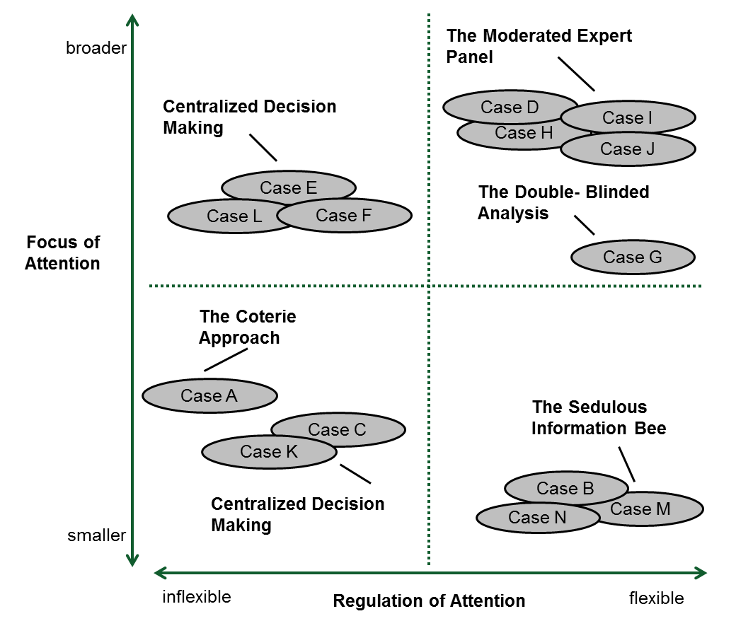
Figure 1: Theoretical framework with incorporated cases

Figure 2: Case E
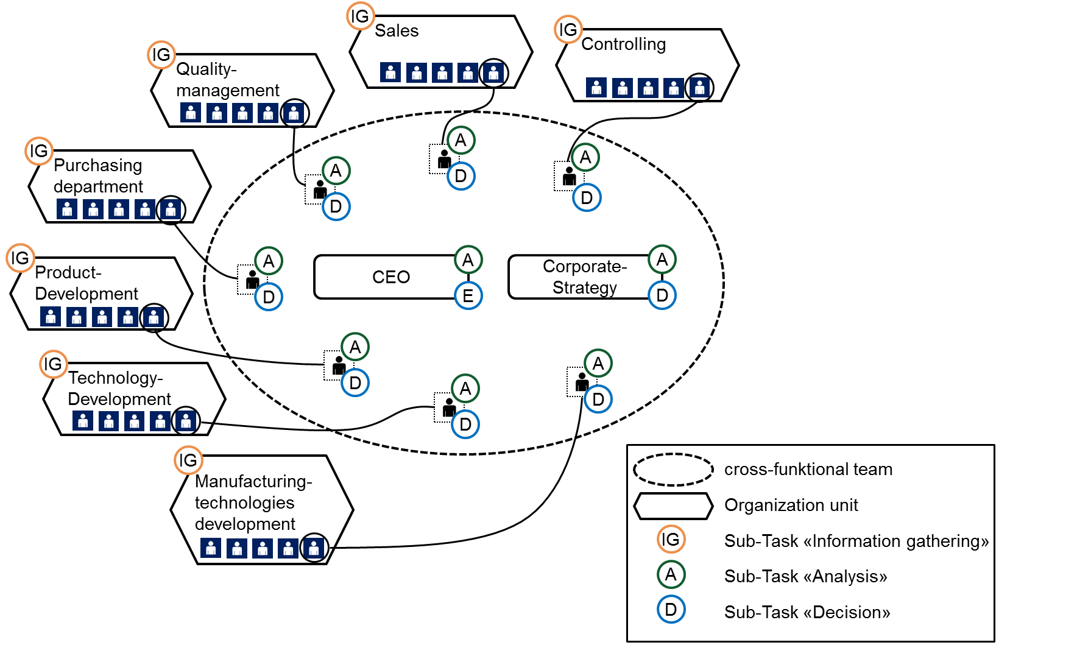
Figure 2: Case E

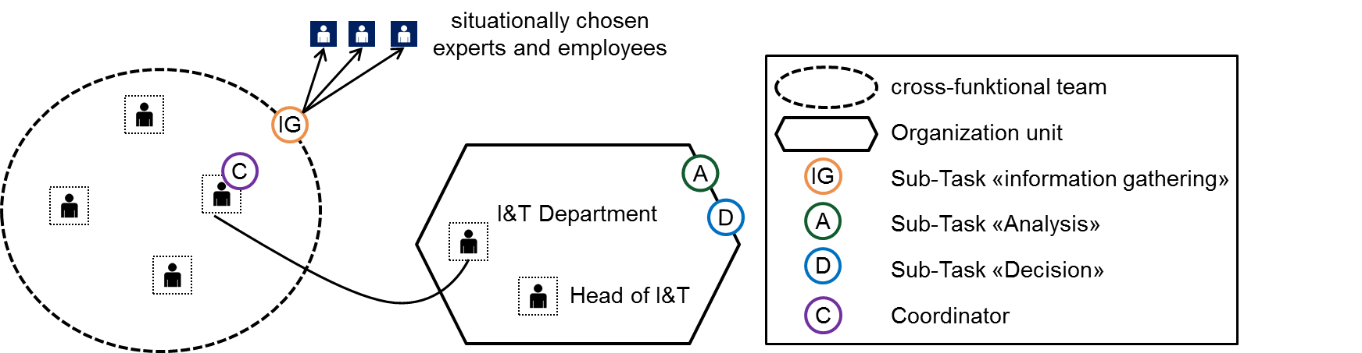
Figure 3: Case N

Figure 3: Case N

Figure 4: Case D
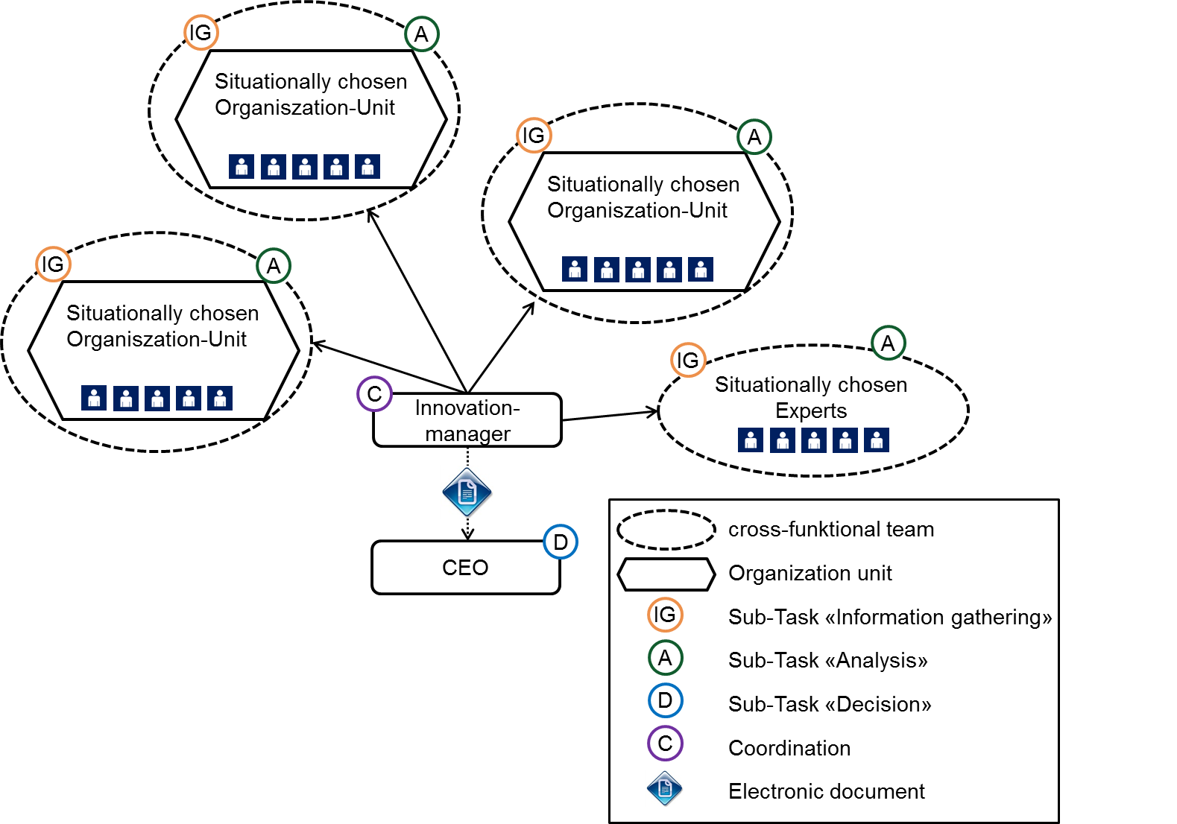
Figure 4: Case D

Figure 5: Case G
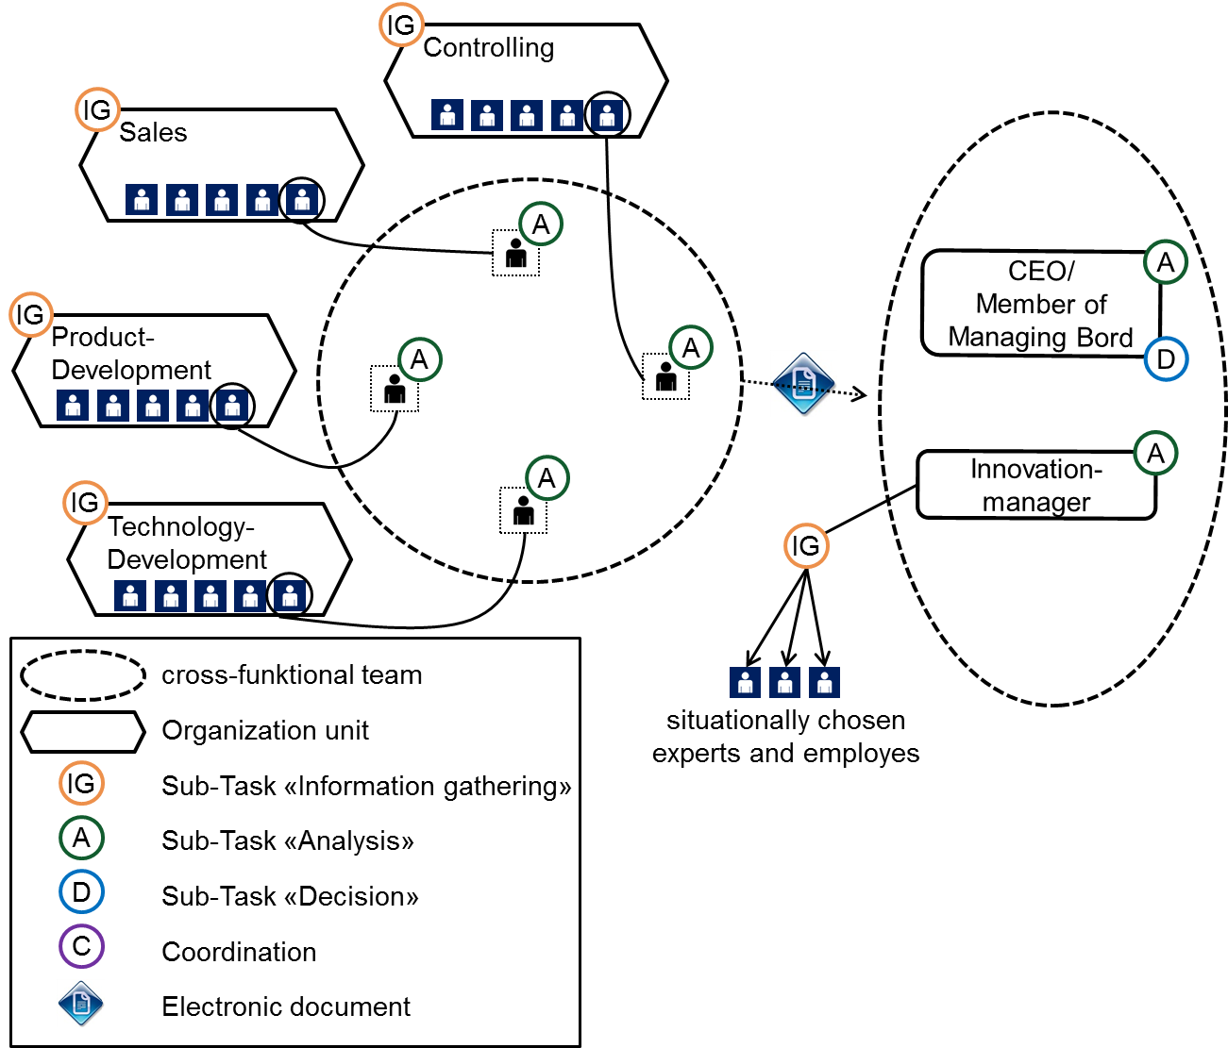
Figure 5: Case G

Figure 6: Regulation of attention depending on perceived uncertainty
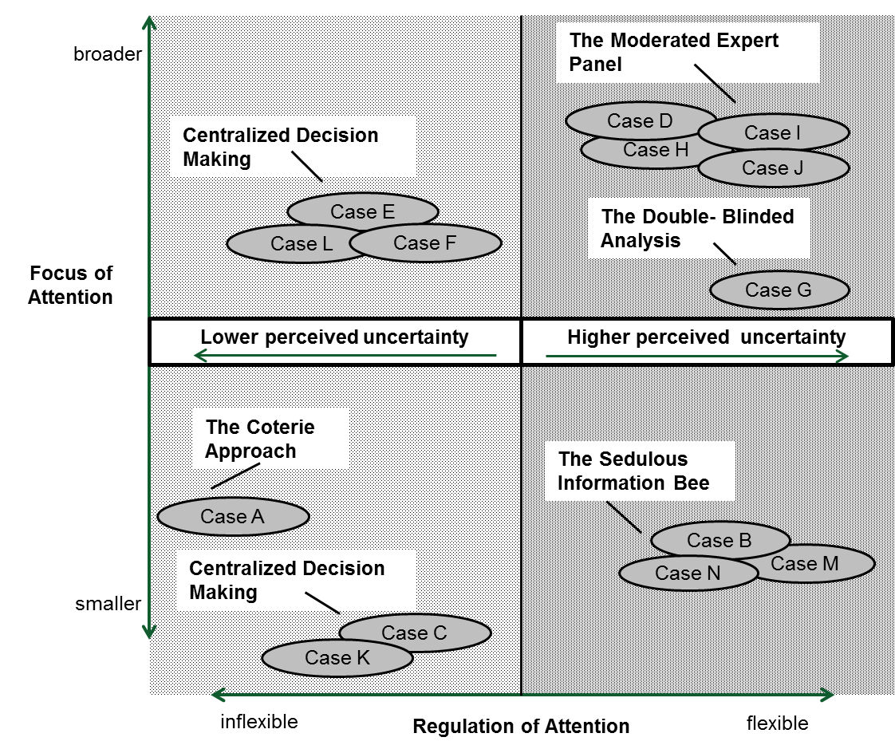
Figure 6: Regulation of attention depending on perceived uncertainty

Figure 7: Focusing of attention depending on perceived impact
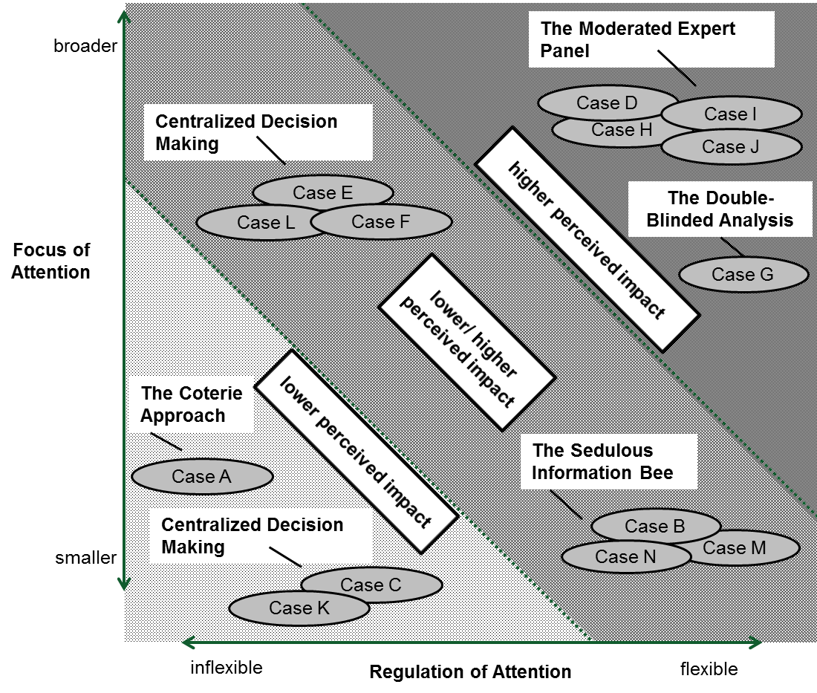
Figure 7: Focusing of attention depending on perceived impact

Figure 8: Application of organizational approaches depending on perceived uncertainty and perceived impact
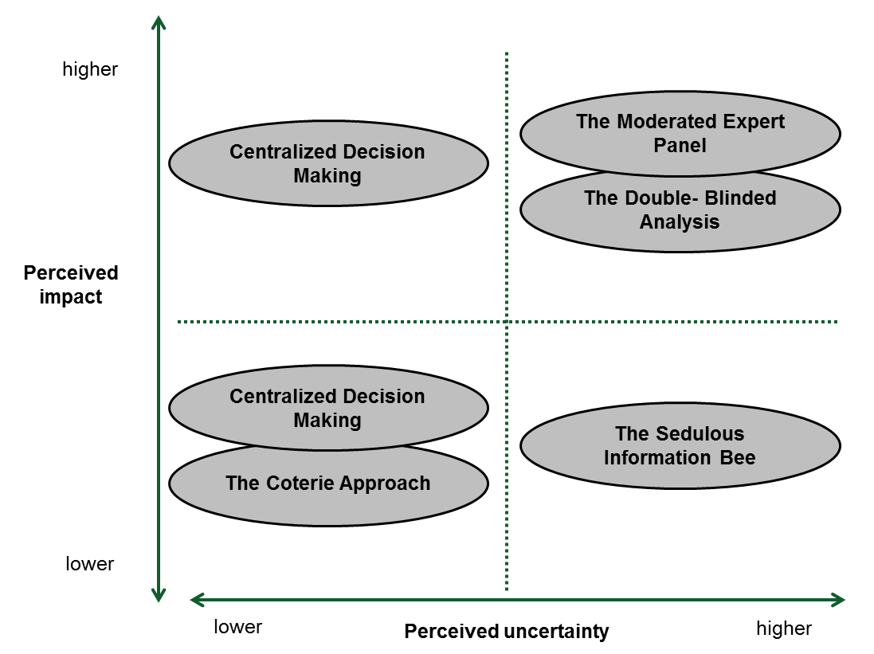
Figure 8: Application of organizational approaches depending on perceived uncertainty and perceived impact

Appendix

A1: Interview guideline for stage one of the case collection
- Sequence plan of technology decisions
- How does the sequence plan for Technology decisions look like in your company?
- At which point during the decision-making process are decisions made and which tasks are implemented?
- Is the decision sequence defined or situational?
- Organizational layout of the technology decision
- Which people (e.g. Innovation manager, CTO etc.) and departments are involved in the process of technology decisions? What task does each of these have?
- Who makes the final decision about the technology?
- Who bears the responsibility for these decisions?
- Knowledge transfer/ communication
- Which departments and people contribute the relevant information necessary for the decision? Are these information collected by individuals or during meetings?
- How are the results of the decision communicated? Which persons and departments are the results shared with?
- How do you evaluate the internal communication in the decision-making process?
- Positive and negative aspects during the decision process
- Regarding the first three points: What works especially well in your opinion?
- Where do you see potential for improvements?

We thank an anonymous reviewer for this suggestion.
We thank an anonymous reviewer for this suggestion.

