CSR Communication Strategies for Twitter
Micro-blogging as a tool for Public Relations

Michael Etter (corresponding author)
Copenhagen Business School
Porcelænshaven 18A
DK-2000 Frederiksberg
Denmark
Tel: +45 50 186 997
Fax: +45 381 53 840
michael.etter@gmx.ch

Thomas Plotkowiak
University of St. Gallen
Blumenbergplatz 8
9000 St. Gallen
Switzerland
thomas.plotkowiak@unisg.ch

CSR Communication Strategies for Twitter
Micro-blogging as a tool for Public Relations

Abstract:
This study explores how companies use the social media tool Twitter for CSR communication. By analyzing CSR communication conducted by 30 most central corporate Twitter accounts, identified through social network analysis within a CSR-Twitter-network consisting of 19’855 Twitter members, we contribute to the understanding of Twitter’s role for CSR communication and public relations. Manually conducted content analysis of totally 41‘864 corporate Twitter messages gives insights into different strategies concerning intensity and interactivity of CSR communication. Based on theoretical foundations and empirical findings four CSR communication strategies for Twitter are identified.

Keywords: CSR, public relations, twitter, interactivity, social network analysis

Introduction

Corporate social responsibility (CSR) has been recognized as an important factor influencing a company’s image and reputation and thereby its stakeholder relations (e.g. Fombrun, Gardberg & Barnett, 2000; Fombrun, 2005; Gardberg & Fombrun, 2006; Pfau, Haigh, Sims & Wigley, 2008; Logsdon & Wood, 2002). By fostering a positive reputation, CSR efforts, ranging from community outreach and environmental protection to socially responsible business practices, have been shown to enhance employee morale (Turban & Greening, 1996), induce a sense of loyalty among both customers and employers (Maignan, Ferrell & Hult, 1999; Riordan, Gatewood & Bill, 1997), improve product evaluations and facilitate buying decisions (Brown & Dacin, 1997; Alexander, 2002). Not at least CSR serves as a goodwill-buffer in times of crisis and safeguards against attacks on a company’s license to operate (Hansen & Schrader, 2005; Klein & Dawar, 2004). However, to profit from CSR efforts, they have to be communicated, preferably in a two-way communication approach, engaging with stakeholders (Dawkins, 2004; Morsing, 2006). Increasingly, the internet is used by companies for CSR communication (Angeles & Capriotti, 2009; Birth, Illia, Lurati & Zamparini, 2008; Rolland & Bazzoni, 2009). Public relations scholars have heralded the Internet for its potential as a tool for interactivity, dialogue and two-way communication (e.g. Kent & Taylor, 1998, 2003; Hallahan, 2001). Facilitating interaction between an unlimited number of individuals, the Internet provides organizations with the unique possibility to develop and sustain relationships (Wright, 1998, 2001) by engaging publics in dialogue, a key characteristic of excellent public relations (Grunig, 1992). Recently the emerge of the Web 2.0 has changed the way of communication and interaction between business and public. In respect to the disclosure of CSR issues, social media have opened new opportunities for CSR related information dissemination and relationship management (Lattemann & Stieglitz, 2007). Social media provide access to stakeholders which could not have been reached in the same intensity before, and enable a more dialogical and personalized interaction (Fieseler, Fleck & Meckel, 2010).
To date, only little research has been done about CSR communication in social media. Very view studies can be found on CSR communication in Twitter. By analyzing the CSR communication of thirty most central corporate accounts in a CSR-Twitter-network, we contribute to the understanding of the role of Twitter for CSR communication and public relations. The purpose of this study is to examine to what extent companies are using Twitter to communicate CSR efforts and thereby employ social media to manage interpersonal dialectic relations by having a dialogic system rather than monologic policies.

Literature Review

2.1 Challenges of CSR Communication

The public relations and communication aspect is gaining a foothold in mainstream CSR research, from the academic (Morsing & Beckmann, 2006; Ingenhoff, 2004; Dawkins, 2004; Bruning & Lendingham, 1999; Manheim and Pratt, 1986) as well as the practitioner side (Birth et al., 2008; Hartman, Rubin, & Dhanda, 2007; Hooghiemstra, 2000). To somehow benefit from CSR activities, CSR communication has become a crucial element as it enables and raises stakeholders’ awareness about CSR activities (Dawkins, 2004; Morsing, 2006). However, CSR communication poses several challenges to corporations resulting in two main key fields of problem: lack of awareness and stakeholder skepticism. Awareness among stakeholder, external as well as internal, about company´s CSR activities is typically low (Du, Bhattacarya & Sen, 2010), hence considered as a key challenge within a company´s aim to gain benefits from its CSR activities. Furthermore, there exists a relevant degree of skepticism, as stakeholders become suspicious of the CSR motives when companies intensively promote their CSR efforts (Forehand & Grier, 2003; Yoon & Gurhan-Canli, 2006). Academics therefore have suggested communicating CSR activities in a way, so that communication measures are not perceived as too intense, as through corporate websites, annual reports or face-to-face communication (Morsing et al., 2008).

2.2 Communication strategies

The buildup of relationships through interactive CSR-communication provides an established measure to raise awareness and lower skepticism. Morsing and Schultz (2006) developed based on Grunig and Hunt’s (1984) characterization of models of public relations three types of stakeholder relations in terms of how companies strategically engage in CSR communication towards their stakeholders. In the stakeholder information strategy, similar to Grunig and Hunt’s public information model (1984), communication is always one-way, from the organization to its stakeholders. Communication is basically viewed as “telling, not listening” (Grunig & Hunt 1984, p. 23), with the purpose of disseminating information, not necessarily with a persuasive intent, but rather to inform the public about the organization. The stakeholder response strategy and the stakeholder involvement strategy are based on a two-way communication model. In both models, communication flows to and from the public, with the difference that the response strategy assumes an imbalance from the effects of public relations in favor of the company. The stakeholder involvement strategy, in contrast, assumes a dialogue with its stakeholders, whereby persuasion may occur, but comes from stakeholders as well as from the organization itself. The strategies developed by Morsing and Schultz (2006) include various communication and information channels in order to establish good public relations. In this paper we focus on the Internet, more specifically the social media Twitter, and its particularities for CSR communication.

CSR Communication in the Web 2.0

Online communication is gaining importance and is increasingly becoming one of the most important information channels for CSR issues (Angeles & Capriotti, 2009; Dawkins, 2004; Ryan, 2003; Birth et al., 2008; Rolland & Bazzoni, 2009). Within recent years technological developments have changed the principles of online communication (Albrycht, 2006; Haythornthwaite, 2005; Meckel & Stanoeska-Slabeva, 2008; Tapscott & Williams, 2008). The traditional way of communicating CSR issues in a one-way communication from the firm to the stakeholder, without any interaction, is giving increasingly way to the Web 2.0 communication broadening possibilities and enabling new kinds of (individualized) interaction between companies and its stakeholders. Not surprisingly, Pressley (2006) identified the enhancement of public relations as one major benefit of using social software for CSR communication.
Despite the high dialogical potential highlighted by researchers, in an early study on CSR communication in social media on ten high CSR-ranked companies Schneider, Latteman and Stieglitz (2007) found that companies are not interested in a direct and public discussion with customers over social media. Nevertheless, more recent studies show an increased activity of companies using social media to communicate CSR in a more dialogical way. Fieseler et al. (2010) propose based on empirical findings on CSR blogs the concept of micro-dialogues created between an organization and highly engaged audiences in online spaces.

Interactivity and Twitter

Scholars have heralded the Internet for its potential as a tool for interactivity, dialogue and two-way communication, arguing that the Internet holds tremendous promise for improving the communication that is an essential part of developing and sustaining such relationships when organizations and publics both have access to online media (Wright, 1998, 2001). Hallahan (2003) sees interactivity as a key factor in the relational processes that leads to relational outcomes. Twitter provides a variety of ways for users to interact (Danah, Golder & Lotan, 2010; Honeycutt & Herring, 2009). First of all, users can declare certain members they are interested in following (friends), in which case they get notified if those members have posted new messages. Furthermore, members are using Twitter to interact with each other directly. To direct a message to another user, Twitter members use the @-sign as a marker to indicate that a tweet is addressed to another user. If members receive messages, they can thereupon reply to this messages with another directed post, enabling an ongoing conversation sometimes resulting in “extended exchange” (Honeycutt & Herring, 2009, p. 1). Further, users can retweet tweets, which can be described as rebroadcasting a Twitter message someone else has posted.
In this study, we will focus on conversational exchanges enabled through directed messages as a person-to-person interaction between a company and its stakeholders. Even though Danah et al. (2010) highlight the conversational aspects of retweeting, in this study we do not analyze retweets, as retweets are by nature not part of conversation between two account holders but rather a contribution to a “broader conversation” (Danah et al., 2010, p. 10) within a network.
Given the functional interactivity of the medium Twitter, in this study it is the aim to analyze if companies actually use Twitter to interact with stakeholders, as found by previous research for blogs (Fieseler et al., 2010), or if companies rather use Twitter as a medium to provide information on CSR without the will to interact as found in early research on CSR communication in social media (Schneider et al., 2007).

Research Questions

Coming from the theoretical background and research made, research questions will be presented in this chapter. With regard to the challenge of low awareness on the one side (Du et al., 2010) and stakeholder skepticism on the other (Forehand & Grier, 2003; Yoon & Gurhan-Canli, 2006), we are particularly interested in how intense companies communicate their CSR efforts in Twitter. In order to determine the intensity of CSR communication following research questions will be applied:

RQ1: How high is the degree of CSR related content in Twitter messages disclosed by companies?

RQ2: How high is the frequency of CSR related tweets disseminated by companies?

With regard to the given functional interactivity of Twitter (Danah et al., 2010; Honeycutt & Herring, 2009) and diverging results about the use of interactive features of social media to communicate CSR (Schneider et al., 2007; Fieseler et al., 2010) we are particularly interested if and how companies use Twitter to communicate CSR towards other Twitter members interactively. Further, we are interested, if companies are responsive and reply to other members´ questions or remarks in Twitter. This leads to following research questions:

RQ3: How high is the degree of interaction of CSR related tweets disseminated by companies?

RQ4: How high is the degree of CSR related tweets, which are dismissed by companies to react on a tweet written by another user?

In the next chapter sample and methodology to answer the four research questions will be described.

Sample and Methodology

4.1 Sample

The selection of the companies for our analysis was based on the 100 best corporate citizen list provided by the Corporate Responsibility Magazine (2010). We draw our choice for high ranked companies on its application by previous researchers (Schneider et al., 2007). The ranking methodology of the ranking list consists of 324 data points of publicly-available information in seven categories including Environment, Climate Change, Human Rights, Philanthropy, Employee Relations, Financial Performance, and Governance.
In a second step we determined the companies with a corresponding Twitter account. Identifying the accounts we did not only rely on the Twitter search feature but also checked the company websites to ensure only the officially created Twitter channels were collected. We excluded companies where a Twitter account under the company name could be found, but which was not run by the company, or there were serious doubts about its validity. Eighty companies out of the 100 were maintaining at least one or more Twitter account, equaling a rate of eighty percent. In a final step we excluded those corporate Twitter accounts, which are specialized in a geographical area (e.g. California), a product or a product segment (e.g. cereals) or in a specific issue except it was related to CSR (e.g. IT), resulting in a total of 165 active and verified corporate accounts, consisting of sixteen specialized CSR accounts and 149 general corporate accounts.

4.2. Social network analysis

In order to determine most central accounts in the CSR-Twitter-network, we first defined the CSR-Twitter-network by iteratively constructing it. We collected 105 "Twitter-seed-accounts", consisting of accounts prominently ranked on publicly available Twitter lists, namely http://www.wefollow.com and http://www.twellow.com, under the keyword “CSR”. To expand our network of CSR interested Twitter users we used the internal list feature from Twitter, which allows every Twitter user to group other Twitter users in topical lists. Such lists can be prolific in determining accounts that share a specific context, in a similar manner like Amazon book lists. Using a self developed Tool (TwitterMiner) we extracted all lists of the 105 Twitter-seed-accounts resulting in a total of 51’223 lists. In order to only maintain lists that strongly focus on CSR, we filtered those lists by CSR-related keywords “CSR”, “Corporate Social Responsibility”, “Sustainability”, and “Citizenship” resulting in 821 lists addressing the selected topics. Those lists contained in total 19’855 Twitter accounts and over 3 million connections between those accounts, which we effectively defined as the CSR-Twitter-network.
To measure the structural position and rank of the identified 165 corporate accounts in the network of 19’855 CSR interested Twitter members, we applied the methods of social network analysis (Wasserman & Faust, 1994). Using the friend/follower relationships that create directed connections between members, we computed the closeness-centrality (Borgatti, 2005), as well as the in- and out-degree for all accounts from the previously defined Twitter network including the corporate accounts. These measures are commonly used in studies to determine opinion leadership among peers in communities (Valente & Pumpuang, 2007). The closeness centrality measure defines members as central regarding their network if a member is close to all other members of the network (Borgatti, 2005). This measure is computed by summing the shortest ways to all members of the network and scaling that value by the size of the network for each member. It is generally implied that a central position improves the efficiency to disseminate information for an actor in a network. Such actors are able to receive and send information fast on the network. By applying the closeness-centrality measure, thirty most central accounts were identified (table 1).

4.3. Coding

To answer the first research question about the degree of CSR related content in Twitter messages disclosed by companies, qualitative content analysis (Holsti, 1969) was conducted. Therefore, messages of the thirty most central accounts were extracted using a self developed Twitter data collection tool (TwitterMiner). From every account tweets were extracted which have been disseminated by respective accounts from its launch date until august 8th 2010, resulting in a total of 41´864 tweets. Based on the categories provided by the Corporate Responsibility Magazine Ranking (2010), namely the topics environment, climate change, human rights, philanthropy, employee relations, and governance, each tweet was coded manually for the presence or absence of CSR related content, whereby distinction was made between CSR topics in general (CSR general) and CSR efforts actually made by companies (CSR company). In order to answer the second research question about the frequency of CSR related tweets, a quantitative analysis was conducted by dividing the total amount of CSR related tweets through the amount of months the corporate accounts have been maintained. To answer the third research question how interactively corporations communicate in Twitter, we analyzed the usage of @-signs. Since not every @-sign implies an interaction, but can also refer to another user or indicate a member´s location (Honeycutt & Herring, 2009), we only included those tweets which were actually addressed to other members. In order to answer the fourth research question, if tweets addressed to other members were a reply, the analysis of tweets containing @-signs was conducted using the meta-information, obtained through the Twitter API (Application Programming Interface) that states if a tweet is a reply.

Empirical Findings

The results of the closeness centrality measurement are shown in table 1, presenting the thirty most central corporate accounts in the previously defined Twitter-CSR-network including the network rank (out of 19’855 members). The most central corporate account has the network rank 358, whereas the lowest lies at 10´487. Content analysis (RQ1) of disseminated tweets lead to the finding, that the average of CSR related content referring to efforts by the company (CSR company) lies at 25.70 percent. However, as indicated by the high standard deviation of 21.32, the results show a high variance, ranging from 0 up to 88.86 percent (table 1).
Regarding CSR related content disclosed by corporate accounts that does not refer directly to respective companies (CSR general), the average lies at 8.49 percent, with a high standard deviation of 10.19. With view on the results, it can be stated that sixteen out of thirty corporate accounts, equaling 53.33 percent, do barely communicate about CSR without a direct company-link (CSR related content < 3%), whereas five accounts, or 16.67 percent, communicate prominently about CSR without a direct link to the companies´ CSR efforts (CSR related content > 20%).
Regarding frequency (RQ2), results show that 10.91 tweets addressing CSR efforts made by the respective companies are disseminated per month on average (table 1). Again, the standard deviation of 7.11 reflects a high variance. The frequency-average for CSR related tweets, not referring directly to respective companies (CSR general), lies at 3.65 tweets per month, with a high standard deviation of 4.36. These findings show again that sixteen out of thirty companies, equaling 53.33 percent, rarely communicate about CSR without a direct company link (CSR related tweets/month < 1), whereas three companies, or 10.00 percent, communicate often about CSR without a direct link to their CSR efforts (CSR related tweets/month > 15).

Table 1: Empirical findings (RQ1-4)

Nr | Twitter account name | Company | Closeness centrality rank in CSR-Twitter-Network | CSR related content in % |  | CSR related tweets/month |  | CSR related @tweets in % | CSR related @replies in %
 |  |  |  | CSR company | CSR general | CSR company | CSR general | CSR company | CSR company
1 | Starbucks | Starbucks | 358 | 3.31 | 0.16 | 8.80 | 0.40 | 45.28 | 81.50
2 | microsofthohm | Microsoft | 595 | 46.36 | 22.74 | 37.40 | 18.30 | 23.49 | 73.53
3 | BrewBetterWorld | G. M. Coffee | 646 | 57.03 | 19.01 | 8.80 | 2.90 | 45.33 | 32.35
4 | FordDriveGreen | Ford | 1435 | 88.86 | 1.59 | 17.80 | 0.30 | 22.51 | 43.18
5 | smarterplanet | IBM | 2480 | 26.63 | 1.21 | 10.70 | 0.50 | 9.09 | 0.00
6 | Ford | Ford | 2896 | 6.25 | 0.31 | 18.00 | 0.90 | 45.81 | 78.49
7 | msftcitizenship | Microsoft | 3072 | 82.58 | 3.55 | 24.40 | 1.00 | 11.72 | 3.33
8 | pepsico | Pepsi | 3201 | 6.99 | 1.06 | 8.30 | 1.30 | 35.17 | 45.10
9 | CiscoSystems | Cisco Systems | 3352 | 2.47 | 0.93 | 1.70 | 0.60 | 8.11 | 33.33
10 | Applied_Blog | Applied Materials | 3886 | 6.99 | 68.65 | 2.40 | 23.60 | 11.11 | 33.33
11 | EfficiencyNow | Johnson Controls | 4703 | 18.89 | 3.63 | 9.40 | 1.80 | 8.08 | 0.00
12 | pepsi | Pepsi | 4899 | 14.27 | 0.19 | 15.50 | 0.20 | 22.67 | 66.67
13 | Microsoft_Green | Microsoft | 5267 | 57.26 | 11.79 | 13.00 | 2.70 | 9.19 | 100.00
14 | dstangis | Campbell Soup | 5373 | 12.51 | 29.71 | 11.30 | 26.80 | 9.50 | 36.32
15 | Accenture | Accenture | 5590 | 7.79 | 0.00 | 2.00 | 0.00 | 0.00 | 0.00
16 | GreenMtnCoffee | G. M. Coffee | 5607 | 4.50 | 1.63 | 7.60 | 2.70 | 29.17 | 57.14
17 | MyStarbucksIdea | Starbucks | 5881 | 5.16 | 0.45 | 2.80 | 0.20 | 20.29 | 93.33
18 | Alcoa | Alcoa | 6011 | 16.78 | 10.57 | 9.10 | 5.70 | 1.00 | 100.00
19 | CocaCola | CocaCola | 7496 | 0.00 | 0.00 | 0.00 | 0.00 | 0.00 | 0.00
20 | RMHC | Mc Donalds | 7641 | 67.70 | 0.70 | 38.70 | 0.40 | 28.36 | 23.44
21 | StaplesTweets | Staples | 7914 | 2.44 | 0.23 | 5.30 | 0.50 | 40.63 | 0.00
22 | hpnews | HP | 8389 | 10.78 | 0.50 | 3.20 | 0.10 | 26.74 | 0.00
23 | MonsantoCo | Monsanto | 8481 | 17.99 | 7.84 | 6.20 | 2.70 | 17.44 | 67.65
24 | Microsoft | Microsoft | 9569 | 8.02 | 0.59 | 10.30 | 0.80 | 5.11 | 14.29
25 | EnergyinBalance | Duke Energy | 9685 | 47.91 | 32.48 | 13.50 | 9.20 | 11.41 | 17.65
26 | sfallender | Intel | 10026 | 70.97 | 25.81 | 6.30 | 2.30 | 4.55 | 50.00
27 | Owens_Corning | Owens Corning | 10070 | 32.18 | 4.60 | 1.90 | 0.30 | 7.14 | 0.00
28 | PGE4Me | PG&E | 10332 | 21.50 | 2.40 | 26.10 | 2.90 | 33.49 | 0.00
29 | DuPont_News | DuPont | 10397 | 22.30 | 2.48 | 4.20 | 0.50 | 1.39 | 100.00
30 | intel | Intel | 10487 | 6.60 | 0.00 | 2.60 | 0.00 | 6.67 | 0.00
 | Mean |  |  | 25.77 | 8.49 | 10.91 | 3.65 | 18.02 | 38.35
 | Standard deviation |  |  | 21.32 | 10.19 | 7.11 | 4.36 | 12.32 | 30.53

The high variances of CSR related content and frequency (CSR company) is presented in figure 1 visualizing the intensity of CSR communication. As figure 1 shows, eleven corporate accounts, which equals a rate of 36.67 percent, address CSR with a low intensity (CSR related tweets/month < 15 or CSR related content < 10%); another twelve accounts, or 40.00 percent, address CSR on a middle intensity-level (CSR related tweets/month = 15-30 or CSR related content = 10-50%); and seven corporate accounts, or 23.33 percent, communicate CSR with high intensity (CSR related tweets/month > 30 or CSR related content > 50%).

Figure 1: Intensity of CSR communication in Twitter

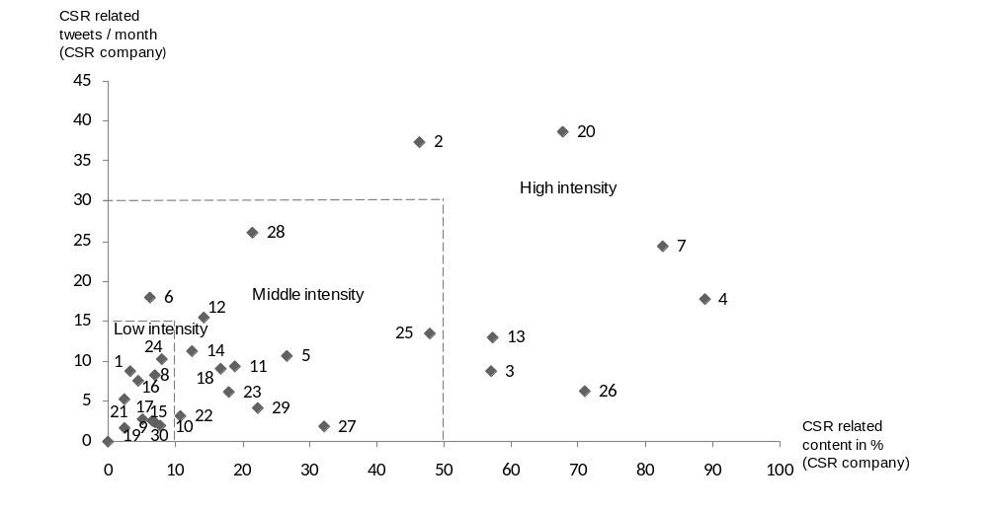

Regarding interactivity (RQ3), results reveal that on average 18.02 percent of tweets addressing CSR related to respective companies (CSR company) contain an @-sign and therefore address other members. However, the high standard deviation of 12.32 reflects the high variance, which is displayed in figure 2: Five accounts, equaling 16.67 percent, exhibit low interaction (tweets with @-signs < 5%), including two accounts with no interaction at all; nineteen accounts, or 63.33 percent, interact on a middle level (tweets with @-signs = 5-30%); and six accounts, or 20.00 percent, communicate highly interactively about CSR on Twitter (tweets with @-signs > 30%).
The answer to the fourth research question (RQ4), whether tweets containing @-signs are a replies, reveals that on average 38.35 percent of tweets containing @-signs dealing with CSR directly related to respective companies are replies. Again, the standard deviation of 30.53 reflects a high variance, depicted in figure 2. It can be stated that twelve corporate accounts, equaling 40.00 percent, have a low responsiveness (replies < 20%); thirteen accounts, or 43.33 percent, a middle responsiveness (replies = 20-80%); and five accounts, or 16.67 percent, show a high responsiveness (replies > 80%).

Figure 2: Interaction and responsiveness of CSR communication in Twitter

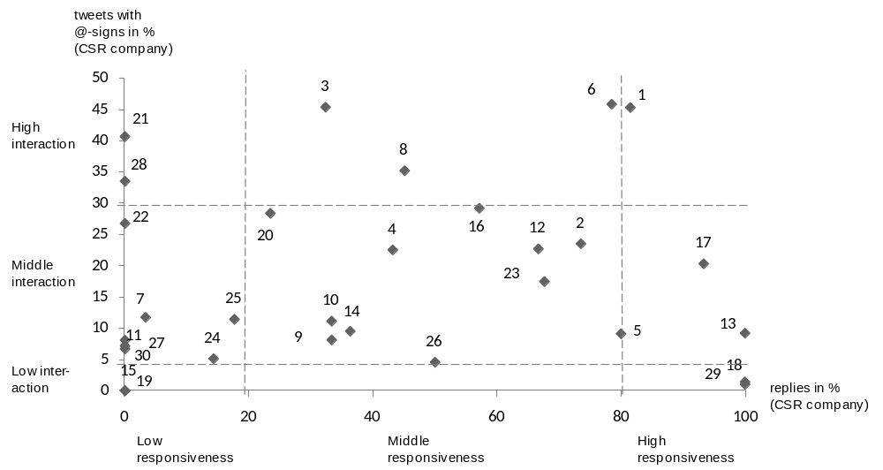

Discussion

6.1
As a practical matter, corporations face unique challenges in communicating CSR interactively online with publics that comprise large numbers of individuals. Twitter enables companies to disseminate CSR related information to an anonymous public, as well as to interested followers, and at the same time address specific Twitter members, or even more reply to questions or remarks directly. Twitter therewith creates new ways of interaction with stakeholders in contrast to traditional corporate websites, which address only a “broad and discerning audience” in mostly one way communication (Coupland, 2005). However, empirical findings of analyzed companies show that intensity of CSR communication as well as the degree of interactivity and responsiveness varies substantially. Whereas certain companies avoid addressing CSR in Twitter (e.g. Cisco Systems), other companies devote prominent space to the topic (e.g. Ford), or even maintain a specific account dedicated to a company´s CSR efforts (e.g. Green Mountain Coffee). Interestingly there exist accounts, which address CSR without a link to the CSR efforts made by respective companies (e.g. Duke Energy), or even communicate substantially more about CSR in general than CSR related to their company (e.g. Applied Materials). Not surprisingly these accounts are specialized on CSR, mostly maintained by people with a strong professional background in CSR (e.g. Dave Stangis for Campbell Soup). Regarding interactivity certain companies show very low interactive behavior (e.g. Alcoa) or communicate mainly reactively (e.g. Starbucks), whereas other companies actively direct particular information to specific Twitter members (e.g. Duke Energy) and moreover openly reply to questions or remarks (e.g. Monsanto).

Four communication strategies

The variances lead to the conclusion that companies apply different communication strategies to address (or not address) CSR on Twitter toward publics who are increasingly geographically and culturally dispersed, and thereby differently conform to the understanding of public relations as a communicative activity that entails ‘‘stimulating feelings such as connectedness, involvement, appreciation, and meaningfulness’’ (Galloway, 2005, p. 573). Based on the model of Morsing and Schultz (2006) we develop a model integrating interactivity and responsiveness of CSR communication in Twitter, emerging in four different strategies (figure 3). Regardless of the strategy chosen, companies can address the subject of CSR with different degrees of intensity. In figure 3 analyzed corporate accounts are assigned to different communication strategies. Thereby, we argue that companies with a very low intensity (CSR related tweets < 3% or CSR related tweets/month < 3) are not following any of the strategies (e.g. Coca Cola).
The information strategy is characterized by low interaction. Accounts with an information strategy mainly disseminate information about CSR, with poor or none interaction and therefore no responsiveness. Clearly these companies – for whatever reason – have no interest in interaction about CSR on Twitter, but rather have the aim to inform stakeholders in a one-way communication approach about CSR efforts, as for example their good intentions, decisions and actions, to ensure positive stakeholder support. Similarly, the personalized information strategy typically involves middle to high degree of interaction and low responsiveness. Accounts with a personalized information strategy disseminate information partly towards specific Twitter members, but thereby hardly answer to questions. Those accounts take advantage of the Twitter-feature of personalization, but demonstrate no or only little interest in replying to other Twitter members publicly. With a rather monologic policy, information is personally directed to other Twitter members to ensure that CSR related content, as for example favorable corporate CSR decisions and actions, are communicated effectively to the company’s stakeholders. The reactive strategy is characterized by middle or high interaction and high responsiveness. Even though they interact, information about CSR still is distributed in a way similar to the information strategy, because account holders with a reactive strategy mainly react rather than actively approach other Twitter members. This asymmetric two-way communication approach is applied by companies which do not actively engage with stakeholders on twitter about CSR, but reply when they are approached, and thereby contribute to a dialogic system without active engagement. In contrast, accounts of the engagement strategy, characterized by middle or high interaction and middle responsiveness, actively address other Twitter members and reply to questions and remarks. Corporate accounts with this strategy disseminate information towards other members personally, and show interest in responding to other users publicly and thereby establish interpersonal dialectic relations. Therefore, the engagement strategy complies best with Bruning, Dials and Shirka‘s (2008) proposition of a dialogue that entails more than just the exchange of information, but explores ‘‘techniques for personalizing organization-public interactions’’ (Bruning et al., 2008, p. 5). By applying the responsive information strategy Twitter has most likely the dialogic potential for a symmetric two-way dialogue. However, the possibilities of Twitter for a dialogue in the Habermasian (Habermas, 1993) definition, as the negotiated exchange of ideas and opinion and the process of open and negotiated discussion, is very limited, considering the maximum length of 140 characters per tweet, the lack of face-to-face communication or temporal constraints. Nevertheless, with its feature of personalized interaction Twitter enables companies to engage frequently and systematically with stakeholders about CSR topics and therewith enrich organization-stakeholder relationships and gain relational social capital.

Figure 3: CSR communication strategies for Twitter

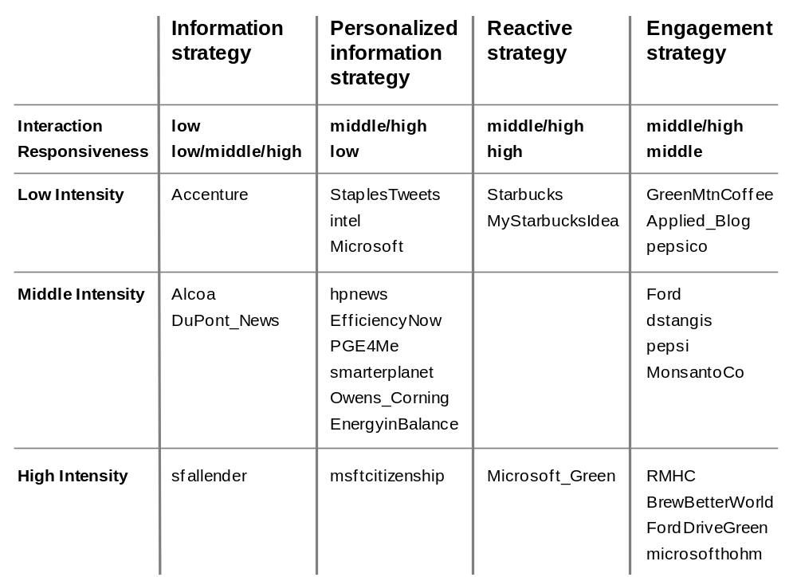

Further research

In order to enhance the understanding of Twitter’s role for public relations, further research is needed: The analysis of CSR related messages on a more qualitative level would reveal which topics are addressed by firms and therefore could depict the practice of companies’ agenda setting in Twitter. Furthermore, results from social network analysis show that ranks from thirty most central corporate accounts in the CSR-Twitter-network range from considerably high to middle ranks. In this study we have not asked about the factors influencing these ranks. The fact, that more than half of the thirty most central accounts in the CSR-Twitter-network are specialized CSR accounts, leads to the impression that high intensity in CSR communication results in a central position. However, companies with very low intensity, as Coca Cola or Cisco Systems, are ranked fairly high, which shows the need for further research on factors influencing the network positions of corporate accounts. Regarding the lack of awareness of CSR efforts made by companies, Twitter, similar to the blogosphere, may not have a direct impact on a large public sphere, but might indirectly reach this larger sphere through opinion leaders. Further research could ask, which members companies are addressing through Twitter, and to what degree these members function as opinion leaders within their networks. Similar, the analysis of retweets disseminated by corporate accounts will reveal, which members companies are retweeting and therefore taking part in a broader conversation of specific networks.

Conclusion
We conclude that Twitter has the potential to raise awareness of a company’s CSR by actively promoting CSR efforts and at the same time minimize stakeholder skepticism through more dialogical and personalized interaction, as favorably applied by the engagement strategy. As an additional communication channel, Twitter increases the degree of interaction facilitating the sharing of (CSR related) information with stakeholders and the development of relationships. Good relationships enable organizations to access more informational, physical and emotional support in the business process, which is in turn a precondition for gaining competitive advantage (Lechner & Dowling, 2003; Liao & Welsch, 2005).

References

Adler, P. S. & Kwon, S. W. (2002). Social Capital: Prospects for a New Concept. Academy of Management Review, 27(1), 17–40.
Albrycht, E. (2006). From information overload to collective intelligence: Social bookmarking, tagging and folksonomy. Public Relations Tactics, 13(1), 16-17.
Alexander, E.C. (2002). Consumer Reactions to Unethical Service Recovery. Journal of Business Ethics, 36, 223-237.
Angeles., M, & Capriotti, M. (2009). Communicating CSR, citizenship and sustainability on the web. Journal of Communication Management, 13, 157-175.
Baker, W. (1990). Market Networks and Corporate Behaviour. American Journal of Sociology, 96, 589–625.
Bhattacharya, C., Sen, S., & Korschun, D. (2008). Using Corporate Social Responsibility to Win the War for Talent. (cover story). MIT Sloan Management Review, 49(2), 37-44.
Birth, G., Illia, L., Lurati, F. & Zamparini A. (2008). Communicating CSR: Practices among Switzerland's top 300 companies. Corporate Communications: An International Journal, 13(2), 182-196.
Borgatti, S. P. (2005). Centrality and network flow. Social Networks, 27(1), 55-71.
Brown, T. J. & Dacin, P. A. (1997). The Company and the Product: Corporate Associations and Consumer Product Responses. Journal of Marketing, 61, 68-84.
Bruning, S. D., Dials, M., & Shirka, A. (2008). Using dialogue to build organizationpublic relationships, engage publics, and positively affect organizational outcomes. Public Relations Review, 34, 25–31.
Bruning, S.D. & Ledingham, J.A. (1999). Relationships between organizations and publics: development of a multi-dimensional organization-public relationship scale. Public Relations Review, 25 (2), 157-170.
Coupland, C. (2005). Corporate social responsibility as argument on the web. Journal of business ethics, 62(4), 355-366.
Danah, B., Golder, S. & Lotan, G. (2010). Tweet, Tweet, Retweet: Conversational Aspects of Retweeting on Twitter. HICSS-43. IEEE: Kauai, HI, January 6.
Dawkins, J. (2004). Corporate responsibility: The communication challenge. Journal of Communication Management, 9(2), 108-119.
Du, S., Bhattacharya, C. B., & Sen, S. (2010). Maximizing Business Returns to Corporate Social Responsibility (CSR): The Role of CSR Communication. International Journal of Management Reviews, 12(1), 8-19.
Esrock, S. L., & Leichty, G. B. (1999). Corporate world wide web pages: serving the news media and other publics. Public Relations Review, 76, 456–467.
Esrock, S. L., & Leichty, G. B. (2000). Organization of corporate web pages: Publics and functions. Public Relations Review, 26(3), 327–344.
Field, J. (2003). Social Capital. London and New York: Routledge.
Fieseler, C., Fleck, M., & Meckel, M. (2010). Corporate Social Responsibility in the Blogosphere. Journal of Business Ethics, 91(4), 599-614.
Fine, B. (2000). Social Capital Versus Social Theory. Political Economy and Social Science at the Turn of the Millennium. London and New York: Routledge.
Fombrun, C. (2005). Building Corporate Reputation Through CSR Initiatives: Evolving Standards. Corporate Reputation Review, 8(1), 7-11.
Fombrun, C. J., Gardberg, N. A. & Barnett, M. L. (2000). Opportunity platforms and safety nets: Corporate citizenship and reputational risk. Business and Society Review, 105(1), 85-106.
Forehand, M., & Grier, S. (2003). When Is Honesty the Best Policy? The Effect of Stated Company Intent on Consumer Skepticism. Journal of Consumer Psychology, 13(3), 349-357.
Galloway, C. (2005). Cyber-PR and ‘‘dynamic touch.’’ Public Relations Review, 31, 572–577.
Gardberg, N. A. & Fombrun, C. J. (2006). Corporate Citizenship: Creating Intangible Assets across Institutional Environments. Academy of Management Review, 31, 329-346.
Grunig, J. E. (1992). What is excellence in management. In E. James & Grunig (eds.). Excellence in public relations and communication management (219–249). Hillsdale, NJ: Lawrence Erlbaum Associates.
Grunig, J. E., & Hunt, T. (1984). Managing public relations. New York: CBS College Publishing.
Habermas, J. (1993). Justification and Application: Remarks on Discourse Ethics. Cambridge, MA: MIT Press.
Hallahan, K. (2001). The dynamics of issues activation and response: An issues processes model. Journal of Public Relations Research, 13(1), 27–59.
Hansen, U. & Schrader, U. (2005). Corporate Social Responsibility als aktuelles Thema der Betriebswirtschaftslehre. DBW, 65, 373- 395.
Hartman, L., Rubin, R., & Dhanda, K. (2007). The Communication of Corporate Social Responsibility: United States and European Union Multinational Corporations. Journal of Business Ethics, 74(4), 373-389.
Haythornthwaite, C. (2001). Introduction: The Internet in everyday life. American Behavioral Scientist, 45 (3), 363.
Haythornthwaite, C. (2005). Introduction: Computer-Mediated Collaborative Practices. Journal of Computer-Mediated Communication, 10, (4).
Holsti, O. R. (1969). Content analysis for the social sciences and humanities. Reading, MA: Addison-Wesley.
Honeycutt, C. & Herring, S.C. (January 2009). Beyond Microblogging: Conversation and Collaboration via Twitter. In Proceedings of the 42nd Hawaii international Conference on System Sciences HICSS. IEEE Computer Society, Washington, DC, 1-10.
Hooghiemstra, R. (2000). Corporate Communication and Impression Management - New Perspectives Why Companies Engage in Corporate Social Reporting. Journal of Business Ethics, 27(1/2), 55-68.
Huang, Y. H. (2001). OPRA: A cross-cultural, multiple-item scale for measuring organization–public relationships. Journal of Public Relations Research, 13, 61–90.
Ingenhoff, D. (2004). Communication of corporate citizenship. analyzing the Dax-Companies. International Agenda Setting Conference, Bonn, 22 September.
Ingenhoff, D. & Kölling, A.M. (2009). The potential of Web sites as a relationship building tool for charitable fundraising NPOs. Public Relations Review, 35, 66-73,
Insch, A. (2008). Online communication of Corporate Environmental Citizenship: A study of New Zealand's electricity and gas retailers. Journal of Marketing Communications, 14(2), 139-153.
Jackman, R. W. & Miller, R. A. (1998). Social Capital and Politics. Annual Review of Political Science, 1, 47–73.
Jahdi, K. & Acikdilli, G. (2009). Marketing Communications and Corporate Social Responsibility (CSR): Marriage of Convenience or Shotgun Wedding? Journal of Business Ethics, 88(1), 103-113.
Kent, M. L., & Taylor, M. (1998). Building dialogic relationships through the World Wide Web. Public Relations Review, 24, 321–334.
Kent, M. L., Taylor, M., & White, W. J. (2003). The relationship between Web site design and organizational responsiveness to stakeholders. Public Relations Review, 29, 63–77.
Klein, J. & Dawar, H. (2004). Corporate Social Responsibility and Consumers’ Attributions and Brand Evaluations in a Product-harm Crisis. International Journal of Research in Marketing, 21, 203–217.
Krishnamurthy, B., Gill, P., & Arlitt, M. (August 2008). A few chirps about twitter. In Proceedings of the First Workshop on Online Social Networks (Seattle, WA, USA, August 18 – 18, 2008). WOSP ’08. ACM, New York, NY, 19-24.
Lattemann, C. & Stieglitz, S. (2007). Online Communities for Customer Relationship Management on Financial Stock Markets – A Case Study from a German Stock Exchange. Proceedings of Americas Conference on Information Systems (AMCIS) 2007. Colorado.
Lechner, C. & Dowling, M. (2003). Firm Networks: External Relationships as Sources for the Growth and Competitiveness of Entrepreneurial Firms. Entrepreneurship and Regional Development, 15, 1–26.
Liao, J. & Welsch, H. (2005). Roles of Social Capital in Venture Creation: Key Dimensions and Research Implications. Journal of Small Business Management, 43(4), 345–362.
Lin, N. (1999). Building a Network Theory of Social Capital. Connections, 22(1), 28-51.
Logsdon, J. M. & Wood, D. J. (2002). Reputation as an Emerging Construct in the Business and Society Field: An Introduction. Business and Society, 41(4), 365–370.
Maignan, I., Ferrell, O. C. and Hult, G. T. (1999). Corporate Citizenship: Cultural Antecedents and Business Benefits. Journal of the Academy of Marketing Science, 27, 455–469.
Manheim, J.B. & Pratt, C.B. (1986). Communicating corporate social responsibility. Public Relations Review, Summer, 9-18.
Meckel, M. & Stanoevska-Slabeva, K. (2008). Web 2.0: The next generation Internet. Nomos: MIT Press.
Morsing, M. & Beckmann, S.C. (eds.) (2006). Strategic CSR Communication. Copenhagen: DJØF Publications.
Morsing, M. & Schultz, M. (2006) Corporate Social Responsibility Communication: Stakeholder information, response and involvement strategies. Business Ethics: A European Review, 15(4), 323-338.
Morsing, M. (2006). Strategic CSR Communication: Telling Others How Good You Are. In J. Jonker, M. de Witte (eds.). Management Models for Corporate Social Responsibility (238-246). Berlin/ Heidelberg: Springer.
Morsing, M. , Schultz, M. & Nielsen, K. U. (2008). The „Catch 22´of communicating CSR: Findings from a Danish Study, Journal of Marketing Communication, 1 (2), 97 – 111.
O’Reilly, T. (2005). What Is Web 2.0: Design Patterns and Business Models for the Next Generation of Software. Retrieved 22.03.2006, from http://oreilly.com/web2/archive/what-is-web-20.html
O’Reilly, T. (2006). Web 2.0 Compact Definition: Trying Again. Sebastopol: O’Reilly Media, http://radar. oreilly. com/archives/2006/12/web_20_compact. html, downloaded March, 22, 2007.
Pfau, M., Haigh, M. M., Sims, J. & Wigley, S. (2008). The Influence of Corporate Social Responsibility Campaigns on Public Opinion. Corporate Reputation Review, 11 (2), 145-154.
Pollach, I. (2005). Corporate Self-Presentation on the WWW: Strategies for Enhancing Usability, Credibility and Utility. Corporate Communications: An International Journal, 10(4), 285–301.
Portes, A. & Sensenbrenner, J. (1993). Embeddedness and Immigration: Notes on the Social Determinants of Economic Action. American Journal of Sociology, 98, 1320–1350.
Pressley, L. (2006). Using Social Software for Business Communication. Working Paper LIS 650.
Riordan, C. M., Gatewood, R. D. & Bill, J. B. (1997). Corporate Image: Employee Reactions and Implications for Managing Corporate Social Performance. Journal of Business Ethics, 16, 401-412.
Rolland, D. & Bazzoni, J. (2009). Greening corporate identity: CSR online corporate identity reporting. Corporate Communications: An International Journal, 14(3), 249 – 263.
Ryan, M. (2003). Public relations and the web: organizational problems, gender and institution type. Public Relations Review, 29, 335-349.
Seltzer, T. (2005). The dialogic potential of Weblogs in relationship building. Public Relations Division at the annual meeting of the Association for Education in Journalism and Mass Communication, San Antonio, TX.
Sundar, S. S., Kalyanaraman, S., & Brown, J. (2003). Explicating Web site interactivity: Impression formation effects in political campaign sites. Communication Research, 30, 30–59.
Tapscott, D. & Williams, A.D. (2008). WIKINOMICS: HOW MASS COLLABORATION CHANGES EVERYTHING. Economic Affairs, 28(4), 88-89.
Taylor, M., Kent, M. L., & White, W. J. (2001). How activist organizations are using the Internet to build relationships. Public Relations Review, 27, 263–284.
Turban, D. B. & Greening, D. W. (1996). Corporate Social Performance and Organizational Attractiveness to Prospective Employees. Academy of Management Journal, 40, 658-72.
Valente, T.W. & Pumpuang, P. (2007). Identifying opinion leaders to promote behavior change. Health education behavior, 6, 881-896
Walther, J. B., Gay, G., & Hancock, J. T. (2005). How do communication and technology researchers study the Internet? Communication and Technology, 55, 632–657.
Wasserman, S., & Faust, K. (1994). Social network analysis methods and applications (paperback ed.). Cambridge: Cambridge University Press.
Woolcock, M. (1998). Social Capital and Economic Development: Towards a Theoretical Synthesis and Policy Framework. Theory and Society, 27(2), 151–208.
Wright, D. K. (1998). Corporate communications policy concerning the Internet: A survey of the nation’s senior-level, corporate public relations officers. Gainesville, FL: The Institute for Public Relations.
Wright, D. K. (2001). The magic communication machine: Examining the Internet’s impact on public relations, journalism, and the public. Gainesville, FL: The Institute for Public Relations.
Yoon, Y., Gürhan-Canli, Z., & Schwarz, N. (2006). The Effect of Corporate Social Responsibility (CSR) Activities on Companies With Bad Reputations. Journal of Consumer Psychology (Lawrence Erlbaum Associates), 16(4), 377-390.

